Precision Guidance System
Robocrop

Users Guide for In-Row Cultivation
Software Version 5.09

Disclaimer
Considerable effort has gone into making Robocrop reliable under normal commercial conditions. However, it is possible that under some adverse circumstances the guidance system will be unable to operate reliably. It is the operator’s responsibility at all times to ensure that the machine is operating in a satisfactory manner. Should excessive crop damage occur operation should cease and if necessary your Garford dealer should be contacted for advice.
Contents

1. Preface.......................................................................................... 3
2. Safety............................................................................................ 5
3. Assembly....................................................................................... 6
Step 1 – Setting up the linkage arms................................................................. 6
Step 2 – Reducing lateral movement................................................................. 6
Step 3 – Levelling the implement....................................................................... 6
Step 4 – Connecting the hydraulic hoses........................................................... 6
Step 5 – Mounting the console........................................................................... 6
Step 6 – Connecting the power supply............................................................. 6
Step 7 – Connecting implement loom to the console.......................................... 7
Step 8 – Starting the tractor and console........................................................... 7
Step 9 – Checking hydraulic operation............................................................... 8
4. Working screen – the basics......................................................... 9
5. Getting to work in the field............................................................ 11
Step 1 – Checking camera height and inclination angle in the field ……….... 11
Step 2 – Stationary alignment to crop rows....................................................... 11
Step 3 – Initial running and adjusting camera lateral position ........................... 12
Step 4 – Running with rotary blades fitted........................................................ 13
Step 5 – Setting camera height and inclination…………………………………… 14
Step 6 – Deriving new camera configuration figures …………………………… 14
6. Notes on operation with a correctly set up machine…………….. 16
7. Information screens and menus…………………………………… 17
Working screen functions………………………………………. 17
Setup menu……………………………………………………… 18
Advanced set up & diagnostics menu………………………... 19
Configuration file editor………………………………………… 22
8. Maintenance and storage............................................................. 28
9. Troubleshooting............................................................................ 29

Copyright notice
The computer vision guidance software and the associated configuration tool on all Robocrop systems are copyright Tillett and Hague Technology Ltd.
This product also makes use of public domain operating system code. Under the terms of the GNU general public licence and/or the University of California, Berkeley (UCB) license copies of the public domain software are available on request.
1. Preface
Congratulations on purchasing a Robocrop precision guided implement.

The Robocrop precision within-row weeder is guided by a computer controlled steering system using video images to detect individual crop plants.
There are 5 main components to the system.
- A video camera or cameras looking ahead at the area of crop to be cultivated.
- An implement mounted computer system to analyse video images and control the system.
- A cab mounted console to display user information including a live video image or images.
- A hydraulic side shift (or steered discs) to keep the camera centrally over the crop rows and the implement precisely on track.
- Hydraulically driven rotary cultivators to cultivate around crop plants within-the-row.
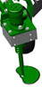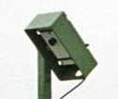

Console
Computers
for rotary cultivators and disk steer/ side shift control
Within-row rotary cultivator
Camera
Schematic of a Robocrop front mounted within-row cultivator
Robocrop uses a colour camera to pick out green crop and weed from backgrounds containing soil, stones and trash. (Consult your Garford dealer for systems to work in red crops.) Robocrop locates crop plants within a scene by matching a template corresponding to the known planting pattern with crop plants as they appear in the camera image. These estimates of plant position are then used to synchronise the rotary in-row cultivation blades with the plants. The advanced template matching and tracking techniques used by Robocrop make it robust to moderate weed infestations. However, severe weed infestations may prevent reliable operation.
The within-row cultivation blades are based on a cut away disc designed to rotate about an axis offset from the crop row such that they cut into the row between plants but withdraw as they draw level with a plant. Disk profiles are designed to suit a particular planting pitch, though in practice one design can be used on a range of plant spacings.
Use of a camera to locate and track individual plants makes it possible to compensate for the normal variability of plant spacing by altering the speed of rotation of the rotary cultivation blades. The system will accommodate the within-row variability (typically +/-25%) to be expected from a well set up modern transplanter. In practice the largest variability in plant spacing is often due to hand gapping up after mechanical planting. Growers using a Robocrop in-row weeder may wish to consider briefing those people doing the hand gapping to take more trouble in achieving a uniform spacing.
The purpose of the working screen displayed on the console is to provide a graphic display of machine status. Graphical icons around the outside of the screen indicate important machine parameters and warnings. At the centre of the display is a live video image allowing the operator to correctly position the implement at the headland and to monitor the quality of plant tracking. As new plants appear at the top of the image green crosses representing plant position are initially placed over the image according to a predicted position based on the plants already located and the known planting pattern. Blue crosses indicating the best local match for plant position in that particular image are also displayed as an overlay (sometimes obscuring the green crosses). As plants progress down the image the green crosses represent a long term average of plant location based on several local matches of plant position through a sequence of images. By the bottom of the image the green crosses represent the final estimate of plant location and it is that position that is used to synchronise the rotary cultivators as the machine passes over the crop.
Machines with multiple cameras have live thumbnail video images across the top of the display. The user can toggle between each of these to select which is displayed full size.
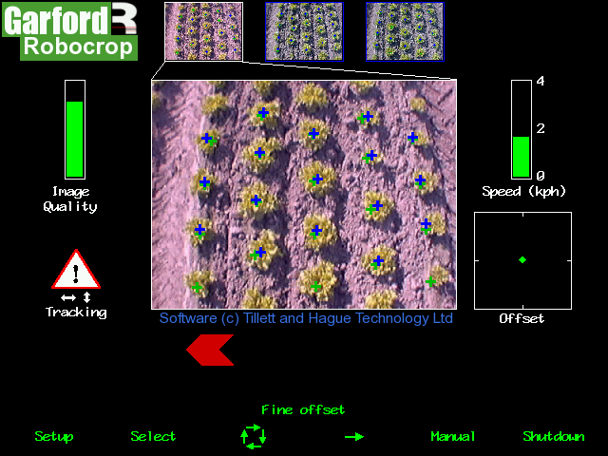
Typical working screen for a three camera system with estimated plant locations overlaid as green crosses and spot measurements of individual plant positions as blue crosses.

Matching a template over a number of rows and looking ahead to a number of plants within-the-row improves reliability over systems based on simple on/off sensor systems, especially when weeds might be confused with crop plants. Template shape is determined by a configuration file pre-programmed to suit a particular crop planting geometry and implement configuration. Different configuration files are available from your Garford dealer for different crops and implements.
An accurate match between the template and crop rows is important for accurate cultivation.

Disclaimer
Considerable effort has gone into making Robocrop reliable under normal commercial conditions. However, it is possible that under some adverse circumstances the guidance system will be unable to operate reliably. It is the operator’s responsibility at all times to ensure that the machine is operating in a satisfactory manner. Should excessive crop damage occur operation should cease and if necessary your Garford dealer should be contacted for advice.
2. Safety

- When carrying out repairs or adjustments to a side shift, steering discs, rotary blade units or implement, ensure that the Robocrop system is switched off and that the hydraulic supply is off. It is also necessary to ensure that the hydraulic accumulator is fully discharged as this component stores oil under pressure and could power movement even with the tractor hydraulic supply disconnected.

- Never conduct maintenance work on the side shift or disk steering mechanisms while they are supporting the implement.

- The side shift and steered disc mechanisms forms pinch, trap and shear points. Be aware of these when carrying out maintenance.

- Regularly check the condition of hydraulic hoses and fittings.

- The hydraulic supply manifold is fitted with a hydraulic accumulator. Discharge the accumulator before disconnecting from the tractor.

- Do not allow other persons to ride on or work near the implement when it is in operation.

- The power supply cable has a 20Amp fuse fitted near to the battery terminals. This is for short circuit protection and must not be omitted.

- When routing the loom and power supply cables ensure that they do not cause a restriction or trip point in the cab.
- When transporting a disc steered front mounted unit on the road the slide locking plate should be engaged and the self centring cable load relief pin should be inserted.

Note:
In-row Robocrop has been designed to operate with tractors using closed centre hydraulic systems that supply flow on demand. The machine will function with open centre hydraulic systems, but the supply of full flow at full system pressure will be energy inefficient and may result in the generation of excessive heat. If the operator chooses to operate In-row Robocrop with an open centre system then it is their responsibility to monitor hydraulic oil temperature. Robocrop’s valves should not be operated with oil above 70 degrees centigrade. Operators should consult the tractor manual for any limitations relating to tractor systems. The generation of heat can be reduced by turning the hydraulic supply off when not required.
3. Assembly
The following steps outline how the Robocrop precision guided implement should be set up.

Step 1 – Hitching to the tractor
Position the tractor and implement on a level surface. Check that the tractor’s lower link arms are evenly adjusted and hitch the tractor to the 3 point linkage points on the side shift frame.
Caution
- The side shift 3 point linkage points are to standard category 2 dimensions and so must be attached to a similar tractor linkage.
- Once the 3 point linkage is correctly fitted stop the tractor and apply the handbrake.

Step 2 – Reducing lateral movement
Adjust the stabiliser links to prevent lateral movement of the lower link arms.
Caution
- For side shifting front mounted systems it is particularly important that there is no lateral movement in the linkage.

Step 3 – Levelling the implement
With the cultivator on the ground, adjust the top link so that the cultivator is level, front to rear.
The control system loom and hydraulic hoses can now be routed from the implement to the tractor.
Caution
- Clipping the loom and hoses to the top link should keep them clear of catch points.
- Make sure that the linkage can be operated over its full range without stretching or chaffing the loom conduit or hoses.

Step 4 – Connecting the hydraulic hoses
Plug the hoses into a suitable double acting valve connection on the tractor. Markers on the hoses indicate the following:
Supply – RED Return - BLUE.

Step 5 - Mounting the console
Mount the console in the tractor cab in a position where it can be clearly seen but does not obscure operator's visibility. Four screws (M6 x 12) and tapped holes in the rear of the console facilitate mounting to a bracket. Use of the suction bracket for mounting on the tractor wind screen is recommended as it provides good vibration isolation.
Caution
- The console should be protected from severe vibration.
- Do not use longer screws than those supplied otherwise damage to the console may result!

Step 6 – Connecting the power supply
The power supply cables from both the implement mounted control box and the cab mounted console should be connected directly to the tractor battery.
Caution
- Route the cables carefully ensuring that they cannot become trapped or chaffed.
- The 20amp fuse at the battery terminal end of the cable is for short circuit protection and must not be removed.
- The polarity is denoted by + and – marker rings on the cables. The fuse is on the + cable.
Step 7 – Connecting the implement loom to the console
The loom from the implement should be routed into the tractor cab and through to the console.
Caution
- Do not to allow the loom to restrict access to or exit from the cab or act as a trip point.
Plug the large multi pin plug into the socket in the bottom of the console.
Caution
- Note the correct alignment of the tabs in the plug and socket and avoid excessive force in pushing the connector together. If you have any problems with this connector consult your dealer as incorrect assembly will seriously damage the computer.

Ensure alignment tabs and slots are lined up when inserting the plug into the socket
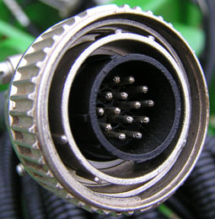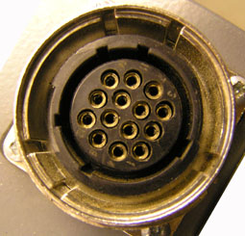

Step 8 – Start up and rotor unit start up test
With the implement still on the ground check that the spool valve is in neutral and all persons are well clear. Start the tractor and switch on the console. Wait for the system to "boot up". After a few screens of familiar PC boot up text a screen will be displayed prompting you to lift the implement. Having done so you will see the message, “Ensure all personnel are clear of the machine”, with the option to begin the start up testing process. Having checked that the area is clear, set the tractors hydraulic control to provide a constant flow to the implement, ensuring that you have the facility to disengage the hydraulic supply immediately should a fault occur.
To initiate the start up test process press the button labelled “begin” at the bottom of the display. The screen will for the next 15 seconds display the message “Synchronising encoders” during which time the rotor units should all rotate. They should ramp up in speed holding at a constant speed for 5 seconds and then ramp down again. If this self testing process has a satisfactory outcome the working screen will be displayed and the side shift or steering discs will centralise if they were not already centred.
If the self test process did not produce a satisfactory outcome an appropriate message will be displayed to help diagnose the problem. These potential messages include “No oil flow?”, “Reverse rotation (Rotor No)” and “Coms fail.” The user has the option via labelled buttons to “Ignore” the result and continue to the working screen, “Retry” the test process, or “Shutdown”. The message “No oil flow” may indicate that the hydraulic oil supply is not reaching the implement or that it is set at a very low flow rate. “Reverse rotation” would indicate that the pipes to the specified hydraulic motors should be reversed. If all the rotary units are specified it may be that the main hydraulic supply is connected incorrectly. If the message “Coms fail” appears check that the connections between the implement mounted control box and the cab mounted console are fully mated and retry the start up test. If the problem persists contact your Garford Dealer.

Step 9 – Checking hydraulic side shift/disc steer operation
With the tractor running, the implement lifted and the console displaying the working screen the side shift/steering discs should have automatically centred.
If the side shift or discs were already central and you wish to test them press the second button from the left on the bottom of the console (labelled “manual” on the working screen). The hydraulic side shift/steering is now in manual mode and can be operated via the third and fourth buttons (labelled with left and right arrows on the working screen). Each press of a button steps the side shift/steering by 3.5% of its stroke. Repeated pressing (but not holding the key down) will result in continuous travel up to the end of the stroke. This procedure can be used to check that hydraulic flow is in the correct direction and that the side shift rate is correct. A normal side shift rate would be 0.1m/s (e.g. 3s to travel a 0.3m stroke). To return to normal automatic mode press the same button (now with “manual” highlighted) again. The side shift/disc will stay in the position it was placed under manual control until the implement is lowered and raised again, or the machine starts to travel forward.

Caution
- Side shift/disc travel all the way to one side on lifting the implement may indicate that the hydraulic supply to the control valve is connected the wrong way.
- Rapid side shift/disc oscillations back and forth about the central position indicate that the hydraulic flow rate to the side shift is too high. To reduce the flow the hydraulic flow control valve on the implement may be adjusted, see picture of valve below with cover removed.
- Only adjust the flow control valve with the implement on the ground and the tractor engine switched off.
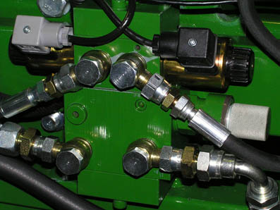

The machine is now ready for work, though before proceeding to the operational phase it is worth familiarising yourself with the working screen.
4. Working screen – the basics

On start up after completing the initial rotary unit tests the console displays the working screen as illustrated below. It has the following features:
- A live camera video image in the centre of the screen. Superimposed over the live video image are two arrays of crosses green and blue. Green crosses represent the estimated position of individual crop plants. They are initially placed near the top of the image according to nominal plant spacing and estimated position of the previous plant in that row. They should therefore be close to, but not necessarily exactly aligned with actual plants in the video image. As they progress down the image observations from successive images (blue crosses) are used to refine this initial estimate so that by the time they reach the bottom of the image they should accurately reflect plant position. It is the last estimate of plant position as they leave the bottom of the image that is used synchronise the rotary disc units.
The blue crosses (superimposed over the green crosses) represent the best fit for the individual plant matching template in that particular image for that particular plant. These observations are combined with previous estimates of plant position to refine that location. If individual plant matching templates cannot produce a good match, the crosses will be displayed as yellow or red. An image with a high proportion of red or yellow crosses is likely to lead to poor tracking. Steps should be taken to improve the situation and cultivation should only proceed with caution.
- Systems operating with multiple cameras will display live thumbnail video along the top of the display. The button labelled “select” toggles between thumbnails for full size display.
- An image quality gauge to the left of the screen giving a reading of likely tracking performance based on a combination of all images. The higher the green bar the better. A low bar indicates either a poor template match or poorly defined plants in the video image. Robocrop will under most circumstances operate down to an indication of approximately 25% albeit at reduced accuracy.
- A warning triangle (shown in the illustration below) indicates poor tracking. If it is displayed with a horizontal double headed arrow Robocrop estimates that the error in lateral implement position exceeds 25mm. If the arrow is vertical Robocrop estimates the phase angle error of at least one of the rotor units exceeds 10°. On seeing this warning the user should slow down or stop and check performance on the ground.
- A speed gauge on the right shows forward speed. This should match tractor speed.
- A green dot and red chevrons below the image indicate side shift position/disc angle. A red chevron with a vertical bar indicates the limit of travel has been reached. This should not occur for extended periods.
- The fine offset gauge shows the amount of left, right, forward or backward bias set by the user. This is used to compensate for minor lateral camera misalignment, but the lateral fine offset can also be useful on side slopes. The fore and aft fine offset alters the phase relationship between the rotary units and the crop plants. It applies equally to all rotary units. See section 7.1 for how to adjust the fine offset. For multi camera systems fore and aft fine offset relates to the rows associated with the image selected for full size display.
Operator controls are via 6 buttons located along the base of the display screen. These are known as soft keys because their function changes depending on the screen being viewed. Soft key 1 (Sk1) is on the left and soft key 6 (Sk6) is on the right. Current soft key function is indicated immediately above the button on the display screen. A full description of these functions is given in section 7 page12.

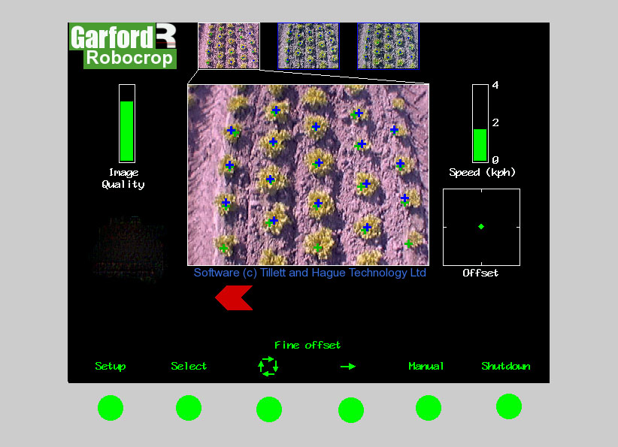

Sk1 Sk2 Sk3 Sk4 Sk5 Sk6

5. Getting to work in the field
The most important procedure to ensure good guidance is to match the template representing the expected planting pattern with the crop plants as they appear in the live video image. The following steps outline how to get the best match and hence good guidance.
Tip: For the first few hundred meters of running after commissioning, or after selecting a different configuration file, Robocrop learns (or re-learns) a term known as camera skew (see section 7.3) Camera skew compensates for minor errors in camera orientation in the horizontal plane. Wherever possible we recommend that set up runs (steps 3 & 4) are conducted in crop showing the clearest rows available at the time so that camera skew is learned as quickly and accurately as possible. High visibility rows also help manual alignment checks (step 2). We also recommend that side slopes and intense partial shadows are avoided during initial running. Once set up is complete more challenging situations can be tackled.

Step 1 – Selecting configuration file and crop size
From the working screen press button Sk1 labelled setup. This switches the display to the setup screen.
The top line of this screen indicates crop size (height) settings under categories of small (<5cm) medium (5-15cm) and large (>15cm). Ensure that the highlighted option corresponds to the crop being used for setup and initial running.
Check the detail at the bottom of the screen to ensure that the configuration file settings selected matches crop and camera geometry.
If configuration settings are not correct refer to section 7 for instructions on making the necessary changes.
To return to the working screen press Sk5 labelled “OK”.

Step 2 – Checking camera height and inclination angle in the field
Draw into a field and set the cultivator down onto a typical section of crop. The cultivator should be set onto the rows as accurately, and as straight as possible.
Press Sk5 labelled “Manual”, The overlaid green lines representing the template of the expected planting pattern should lock in the centre of the screen.
Caution: If the overlaid green lines are not symmetrical on the screen (by more than 4 degrees) the camera skew value may require investigation. Refer to the advanced set up & diagnostics menu in section 7.3.

The green lines superimposed over the live image should align with the crop rows as illustrated below. For best results there should be at least 1/4 of a row spacing between the edge of the image and the outer rows at the bottom of the image. The rotor units should also be close to, but just out of view at the bottom of the image. If either of these is not the case please consult your Garford dealer.
✓
If the template is parallel too, but narrower or wider than the crop rows, check that the correct crop size has been selected. If the crop setting is correct then either the camera height, or the value given in the configuration file (displayed on the set up screen), will need adjusting. Please consult your Garford dealer. (The procedure for physically setting camera height and inclination for a given configuration are given in step 5 and the procedure for creating a new configuration is given in step 6.)
✗
✗

If the template matches at the top of the screen but not at the bottom, or vice versa, check that the implement is set horizontal. (The top link should not be used as a method of controlling cultivator depth). If the implement is horizontal then either the camera angle to the vertical or the values of camera height or look ahead in the configuration file (as displayed on the set up screen) need to be adjusted. Please consult your Garford dealer. (The procedure for setting camera height and inclination for a given configuration are given in step 5 and the procedure for creating a new configuration is given in step 6.)

✗
✗

Good tracking will only be achieved if the template lines are centred on all of the rows being tracked.
The superimposed green grid lines also have tick marks (not shown in the illustrations above) corresponding to the nominal plant spacing corrected for perspective. Whilst the tick marks should not be expected to align with specific plants, the space between ticks should approximately correspond to the distance between plants as they appear in that area of the image. If after allowing for normal variability the plant spacing do not match up to the tick marks the nominal plant spacing set in the configuration file (displayed on the set up screen) should be re checked and if necessary changed (see section 7).
For multi camera systems Step 2 should be repeated for each camera (use Sk2 “Select” to toggle between cameras)

Step 3 – Initial running and adjusting camera lateral position
When you are happy you have a good template match press the button labelled “Manual” again to return to the normal working screen ready for tracking. You can be sure that the machine is ready for tracking if an array of blue and green crosses have appeared corresponding plants as they appear on the display.
Tip: In order simplify the set up procedure it is suggested that initial running is conducted with the rotary cultivation blades removed. This allows the operator to concentrate on inter-row cultivation and lateral alignment before introducing within-row cultivation.
Note: For initial set up runs almost all the crosses should be coloured green or blue and form a relatively straight lines corresponding to the crop rows. If this is not the case, or a triangular tracking warning symbol is displayed, either the machine is not correctly set up, or the crop rows are not sufficiently well defined for initial running.
If tracking appears good set off slowly into the crop. The implement should quickly align with crop rows. It is likely that after a short distance it will have settled at a small lateral offset. Small offsets can be corrected using the fine offset facility available from the working screen (see section 7.1). Each press of a left or right arrow key biases the side shift in steps by 1cm (3/8”). Continue down the field stopping occasionally to check lateral position. If the required fine offset exceeds the available number of steps the camera should be physically moved as described below and step 4 repeated.
After approximately 500m of running Robocrop should have learnt camera alignment and lateral bias should therefore have stabilised. If the fine offset is set to greater than two steps we recommend physically moving the camera along the toolframe by the equivalent distance and resetting the fine offset to zero. Where multiple cameras are fitted on a single section all should be moved by the same amount.
Tip: If the fine offset is set to the left then the camera(s) should be moved to the right as viewed from behind looking forward.

Step 4 – Running with rotary blades fitted
Once you are confident that Robocrop is tracking laterally accurately and reliably the rotary blades appropriate for the nominal within-row plant spacing can be fitted. Ensure that the fine offset position in the fore and aft direction is central (see section 7.1) and place the implement down so that the rotary blades are at least two plant pitches behind the first plant. Failure to observe this may result in damage to the first plant in each row as the system may not have time to synchronise.
Set off at low speed. After the first few plants have been passed the accuracy of cultivation around plants should be examined. If the cultivators are consistently cultivating around a point that is ahead of crop plants the fine offset should be moved down using the down arrow. Each button press corresponds to 1cm (3/8”) of phase shift. Similarly if the rotary cultivators are cultivating about a point behind the plants the up arrow should be used (see diagram below).
Cultivated area
Un-cultivated area
Un-cultivated area
Un-cultivated area
Cultivated area
Cultivated area
Problem: Cultivation ahead of plant
Solution: Press fine offset down arrow key
Problem: Cultivation after plant
Solution: Press fine offset up arrow key
Correct set up with cultivation symmetrically around plant
Illustration of how to use fine offset to match the centre of cultivation with crop plants
Multiple camera systems require fore and aft offset to be checked separately for each camera and its associated rotors.
Once you are confident that Robocrop is tracking accurately and reliably, both laterally and fore and aft, forward speed can be increased. The nominal maximum speed corresponds to an average of two plants per second per row. However, in order to achieve this rotors will momentarily exceed these speeds as they compensate for variable spacing within-row. It follows then that the actual maximum speed will also be a function of within-row variability. A very uniform spacing will facilitate a higher maximum speed than a crop that was planted with high variability. In practice excessive speeds will result in a tracking warning in the fore and aft direction. Should that occur the speed should be reduced to a safe level below that at which the warning appears.
The maximum linear speed can be obtained by multiplying the maximum rotary speed by the plant pitch, thus for a 50cm plant spacing the nominal maximum speed is 1m/s (3.6kph). For a spacing of 25cm the nominal maximum is 0.5m/s (1.8kph). In many cases the maximum forward speed will be limited by the mechanical effect of cultivators on the soil and its effect upon plants.
It is the operator's responsibility to decide at which point the vision guidance system becomes 'lost'. If the system losses track of crop plants the operator should cease cultivation and seek to establish the cause of the problem. If necessary your Garford dealer should be consulted for advice.
Garford accept no responsibility for damage to or loss of crop whatsoever.
If satisfactory tracking both between and along rows has been achieved steps 5 and 6 can be omitted and the machine is ready for use.

Step 5 – Setting camera height and inclination (for a given configuration)
Note: Camera height and inclination will normally be factory set and should not require adjustment. However, should adjustment be necessary, due to accidental damage etc, the following instructions should return the system to its original factory state.
Set the implement down onto a flat surface so that it is resting on its depth wheels at its normal working height. (If the implement is disc steered ensure that the discs are not preventing it from settling onto the depth wheels.)
It is important that the top link is set to make the cultivator horizontal when in its working position.
Select the set up screen and note the figure for “Camera height”. Now adjust the camera height (measured to the centre of the lens) above ground level so that it matches this figure.
Using a plumb or spirit level mark the point on the ground vertically below the camera (centre of lens). Then measure forward from this point along the ground by the distance given as “camera look ahead” on the set up screen. Mark this position in such a way that it can be seen in the live video image.
Next return to the working screen and press the button labelled “Manual”. A set of green lines and a central set of cross hairs will be superimposed over the live video image. Adjust the camera inclination (angle to the vertical) so that the cross hairs coincide with the mark on the ground.
Note When you are satisfied that both height and look ahead distances are correct ensure that all clamping bolts are tight as even small movements in camera position will have significant effects on rotor synchronisation with plants.

Step 6 – Deriving new camera configuration figures (required only after major hardware changes)
Adjust the height of the camera so that all the crop rows are in view at the bottom of the image with at least half a row spacing clear on either side. The inclination of the camera should now be adjusted so that the bottom of the field of view is close to, but not actually showing the rotary cultivator units. As these two adjustments interact it may be necessary to repeat these procedures until both conditions are satisfied.
It is now necessary to make two measurements. First the height of the camera (centre of lens) above ground level. Secondly the distance along the ground from the centre of the image (defined by cross hairs superimposed on the live image when in align mode) and a point vertically under the camera (centre of lens). These two dimensions should then be entered into the configuration file as “Camera height” and “camera look ahead” respectively. Your Garford dealer would normally do this for you but experienced users can enter their own figures using the editor as described in section 7.4.
If the machine has more than one camera the process should be repeated for each camera.
6. Notes on daily operation with a correctly set up machine
- Before operation check that electrical and hydraulic connections are secure and that there are no obstructions to side shift/disc movement.
- On first setting the implement down in the field check for each camera that the green and blue crosses line up with crop plants and form relatively straight lines corresponding to crop rows. There should be few yellow or red crosses.
- Proceed with caution for first few meters checking that Robocrop’s speed gauge matches the tractors and that implement alignment is good. If performance is satisfactory speed can be increased. Robocrop’s within-row tracking should be satisfactory up to 2 plants per second, though soil movement considerations may dictate a lower operating speed.
- Robocrop remembers the fine offset settings from previous sessions and so there should not normally be any need to adjust this unless changes have been made to camera position.
- Operating on side slopes will result in some lateral error due to the tractor “crabbing” across the slope. Normally this is not significant, but in extreme cases it may be necessary to use the fine offset function to compensate. If operating in this way remember to reverse the bias when heading in the opposite direction and to return to a neutral setting when stopping work or moving to a flat area. A similar technique can be used to compensate for crop bent laterally by a cross wind.
- Each time the implement is lifted at row ends it will centralise ready for the next run.
- At the end of the day shut down the system by pressing the button on the far right labelled 'Shutdown' and wait until the report 'system halted' is displayed, then switch off the power. It is also advisable to discharge the hydraulic accumulator by reversing the tractor hydraulic supply spool briefly. The implements pressure gauge indicates if this has been achieved.

If in doubt about any machine settings or operating procedures please contact Garford Farm Machinery on +44 (0)1778 342642.
7. Information screens and menus

Robocrop has a graphical working screen that conveys all the information necessary for normal operation. A description of this screen is given in section 4.
A series of six buttons along the bottom of the display allow the operator to access user controls such as fine offset and manual control of side shift/steered discs. The function of these buttons is described by labels on the video screen immediately above each button.
Set up procedures and more advanced information can be accessed via additional screens that can be navigated to via the working screen. The function of the six buttons below the display, known as soft keys, changes with each screen, but is always described by the label displayed above.
7.1 Working screen functions (see section 4 for an explanation of the graphics)
Sk1 Labelled “Setup” this button accesses the setup menu (section 7.2).
Sk2 Labelled “Select” on multi camera systems and blank for single camera systems. This button toggles between cameras affecting the main image displayed and the context of the fine offset.
Sk3 Repeated pressing of this button changes the function of Sk4 from left, right, fore and aft arrows as required to alter the fine offset. (Except in manual mode when this button moves the side hift/steered discs left in steps)
Sk4 Moves fine offset in the direction of the arrow selected (using Sk3). Both lateral steps and fore and aft movements are in 1cm increments. (Except in manual mode when this button moves the side shift/steered discs left or right in steps) For multiple camera systems the fore and aft fine offset relates to the rotors associated with the camera selected for main display.
Sk5 Labelled “Manual” this button switches the system into manual mode. It disables the vision system and allows the user to move the side shift/steered discs left or right manually in steps of 3.5% of potentiometer stroke for each press of Sk3 or Sk4. To prevent mechanical damage this function only operates when the implement is lifted or moving forward.
This button also locks the green lines representing the template of the expected planting pattern centrally in the picture whilst retaining a live video image. This is useful when making camera adjustments to match crop rows with the template.
Pressing the button again resumes normal vision guidance. The side shift/discs remain in the position they were placed manually until forward movement under vision guidance is commenced, or an implement lift is detected. The later will centralise the side shift/discs. Manual mode is exited automatically if the implement starts moving.
Sk6 Pressing this button labelled “Shutdown” enters a shut down screen from which you can elect to continue with the shut down process by operating SK5, labelled “exit”. Wait until the script says ‘system halted’ then turn off the main power switch.
Sk1 Sk2 Sk3 Sk4 Sk5 Sk6
7.2 The Setup Menu
The setup screen can be reached by pressing the appropriate button (Sk1) from the working screen. Two settings “Crop size” and “Configuration” can be altered in the Setup menu.
Navigation within the set up screen is achieved by moving the cursor over options using buttons labelled with arrows (Sk2-Sk4). When the cursor is over an appropriate setting it can be selected by pressing the button labelled “OK” (Sk6)
“Crop size” increases template size to compensate for the crop canopy getting closer to the camera as it grows. This avoids physically adjusting camera height when moving between crops of different heights. Robocrop has settings for small, medium and large crops. As a guide, crops up to approximately 5cm (2”) high are regarded as small, 5cm (2”) to 10cm (4”), medium and greater than 10cm (4”) high, large. On initial set up the default will be medium, though Robocrop remembers crop size from the previous session regardless of which configuration file was used.
“Configuration” allows the user to select between alternative pre-programmed configuration files when going to work on crops with different planting geometries requiring different templates.
The main parameters of the chosen configuration file are displayed at the bottom of the setup screen, they are:
Viewing - Number of rows being used for tracking.
Spacing - The row spacing between the rows being viewed.
Plant spacing – Nominal spacing between plants within-the-row.
Camera height - Distance vertically from lens to ground when in work
Camera look ahead – Horizontal distance in the ground plane between a point vertically below the camera lens forward to the centreline of sight (cross hairs in “align” image).
Camera number (and type, e.g. colour or IR)
Hoe mounting configuration – options for front or rear mounting
and type of lateral actuation employed - options for side shift or steered (discs)
If a suitable configuration is not available this can be created. We recommend that customers ask their Garford distributor to produce an appropriate configuration file. However, experienced users can use the configuration file editor (section 7.4) to create their own.

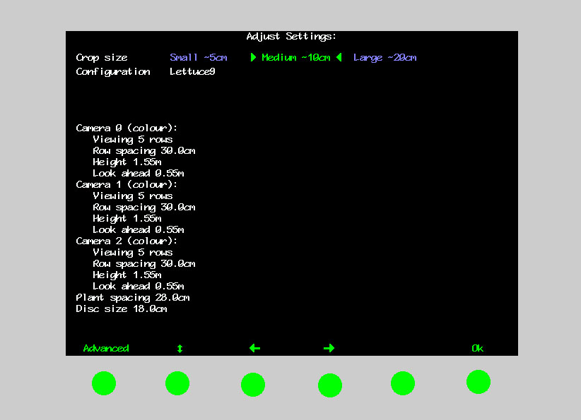

Sk1 Sk2 Sk3 Sk4 Sk5 Sk6

7.3 Advanced set up & diagnostics menu

This screen is intended for advanced users only. It is reached from the set up screen by pressing buttons Sk1. Navigation within this screen is similar to that used in the set up screen.

The first five items on this screen are for information only and cannot be changed by the user. Last check point gives the date/time of the last time operational settings were stored in flash memory as set within the computer and not necessarily actual time. Area worked is based on distance x width.

The remaining items on this screen are as follows:

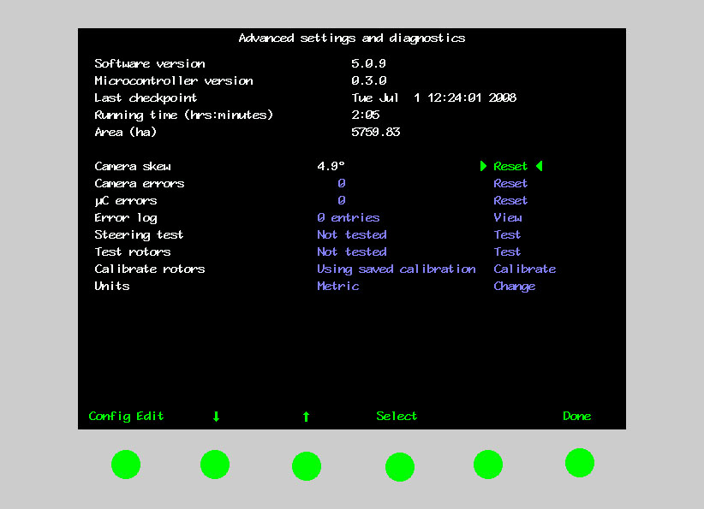
Sk1 Sk2 Sk3 Sk4 Sk5 Sk6

Camera skew
Camera skew is the angular misalignment of the camera in the horizontal plane. This angle is estimated by Robocrop’s computer programme during field operations. The rate of change of this estimated angle is highest during initial runs, after resetting to zero, or when a different configuration file is selected. It stabilizes after approximately 500m of running. During this initial learning phase it is sometimes necessary to readjust the fine offset (section 7.1).
The purpose of estimating angular misalignment and automatically compensating is to avoid the need for very accurate mechanical setting up.
As camera skew relates to a particular camera poise it is necessary to reset it to zero and allow it to estimate a new value each time the camera is moved either deliberately or by accident. Small lateral camera adjustments by sliding within the stroke of the supplied camera bracket should not however require a reset, as camera poise should not be significantly affected. A reset to zero is achieved by highlighting reset and pressing button SK4 labelled select.
There are as many cameras skews as there are cameras. In the example above only one camera is fitted.
Caution
After resetting camera skew it will probably be necessary to reset the fine offset.
Camera skews in excess of 4 degrees indicate poor camera alignment requiring improvement.
Camera errors
This is the number of camera errors automatically logged by the system during the current session. To reset it to zero highlight “reset” and press button Sk4 labelled select.

μC (Micro-controller) errors
This is a log of the number of errors during the current session relating to communications between the main computer and a micro-controller mounted on the implement. To reset it to zero highlight “reset” and press button Sk4 labelled select.
Error log
This is a log of a number of different automatically generated error messages (camera connections, micro-controller connections and excessive camera skew). Selecting “view log” displays single line messages that can be helpful with diagnostics. Not all messages indicate serious faults. On exit you have the option to select “clear” which erases the messages or close which returns to the advanced set up & diagnostics menu without erasing. These messages are saved between sessions.
Steering test
This is a test function that checks a number of components and settings relating to side shift or steering angle movement. Included in the test are micro-controller communication with the main computer, direction of hydraulic flow, rate of flow (too fast or too slow), correct side shift/disc potentiometer connection polarity and continuity over the stroke. It also detects mechanical obstructions preventing full travel. This is achieved by exercising the hydraulic cylinder and recording the response. It is therefore necessary to turn the hydraulic supply on.
Caution
Ensure that the side shift/disc steering mechanism is clear of obstructions and people before operating the hydraulic test function.

Test Rotors
This is a test function relating to the control of the rotary cultivator units and provides a more rigorous test that that routinely conducted at start up. It is necessary to turn the hydraulic supply on and you will be prompted to lift the implement and select “begin”. The screen will display a blank graph with rotor speed (revs/s) on the vertical axis and solenoid current (amps) on the horizontal axis. The first rotor will start to rotate and as it does so two lines are plotted on the graph. The red line represents the systems stored calibration for that particular unit and the green line shows actual performance during the test. Due to hysteresis effects one should expect the rising green line to follow the red line displaced slightly to the right as the rotor accelerates and as it decelerates the falling green line should be displaced slightly to the left. The green line should be relatively smooth, though a small amount of ripple is acceptable. Sizable spikes in the green plot may be symptomatic of component faults. A green line smoothly ramping up and down that does not follow the red calibration plot suggests that the unit needs recalibrating. The test sequence lasts approximately 20 seconds per rotor. Once the first rotor has tested the system goes on to test each of the remaining rotors in turn refreshing the graph on each occasion.
If the test was passed without problem the user is given the message “test passed”. If an error is detected a diagnostic message is displayed. “Rotor too slow” would suggest that insufficient oil was available. “No oil flow” would indicate that the hydraulic supply might not be switched on or connections have not been made. “Reverse rotation (rotor no)” suggests that the hydraulic pipes to the identified units are fitted the wrong way round. “Coms fail” indicates a communication error between the main computer and the micro controller. To return to the advanced set up and diagnostics screen press “done” and repeat the test once the cause of the fault has been addressed.

Calibrate Rotors
This option goes through the same process as the rotor test with the exception that the red calibration line is not displayed as the rotors are run up in turn. If the calibration process was successful the message “Calibrated OK” is displayed and the user is given the option to save the calibration, discard it or use defaults. Once one of these options is selected the user is returned to the advanced set up and diagnostics screen.
If an error is detected during the calibration process a diagnostic message is displayed. “Rotor too slow” would suggest that insufficient oil was available. “No oil flow” would indicate that the hydraulic supply might not be switched on or connections have not been made. “Reverse rotation (rotor no)” suggests that the hydraulic pipes to the identified units are fitted the wrong way round. “Coms fail” indicates a communication error between the main computer and the micro controller. To return to the advanced set up and diagnostics screen press “done” and address the cause of the fault. Once the cause of the fault has been addressed the calibration can be run again.

Units
Selecting toggles between metric and imperial units. This change affects all user screens and the configuration file editor.

To exit the advanced set up and diagnostics menu screen press Sk6 labelled “done”.
7.4 Configuration file editor
Configuration files store information relating to a specific crop planting pattern and implement/tractor geometry that is necessary for plant tracking. Each combination of a different crop pattern or implement geometry requires its own configuration file.
The configuration file editor is intended for experienced users only. It is reached from the advanced set up and diagnostics menu by pressing button Sk1 labelled “config editor”.
Less experienced users are advised to contact their Garford dealer who can supply them with customised configuration files.
This editor requires a standard PC keyboard to be connected to the PS2 socket on the base of the console. Console buttons are not used.
Overview of screen display and how to edit files
Navigation through the editor is via keyboard arrow keys with the enter key used to select a highlighted option. A context sensitive help is available by pressing the ? key with the cursor on the relevant title.
The top line lists the configuration files already stored on the machine, though this can wrap onto another line if there are a large number of files. (If this list does wrap, the continuation line is reached by continuing to press the horizontal arrow key)
The second line provides options to save and exit, create a new configuration file based on defaults (“New”) or an existing file (“Copy”), toggle between metric and imperial units (also possible from advanced set up and diagnostics menu), and select between standard and advanced versions of the editor. In the vast majority of cases the options available on the standard editor are all that is required. The advanced version offers the same features with some additional settings that would normally be factory set. Do not use the advanced editor without consulting Garfords.
The settings and their values displayed on the remainder of the screen relate to the file selected on the top line, or give default values if a new file has been selected. To edit a selected file press the enter key. The cursor will jump to the first setting option which can be edited using the keyboard in the normal way. Pressing Esc will return the cursor to the headings. When you have finished creating or editing a file select Save & Exit and press enter.
Note: When you next run Robocrop you need to select the appropriate configuration file.
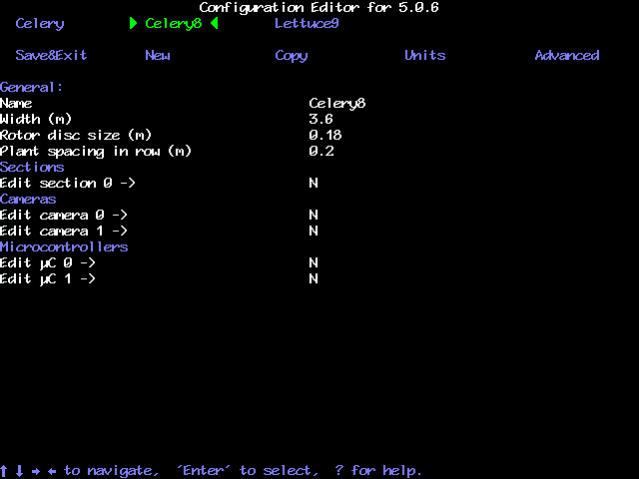
Configuration file editor screen with standard settings selected

Settings available from the standard editor
General settings
The first setting provides an opportunity to change the configuration file name. Implement width is the second standard editor implement setting. The third, rotor disc size, is a parameter relating to disc design that is available from Garfords. It is usually less than the average plant spacing. The final setting is the average within-row plant spacing.
The remaining categories of settings relate to machine sub components. In all cases it is possible to have more than one of these sub components on a single machine. For example a machine may have two cameras so there will be the option to edit the settings for each of these cameras independently as illustrated in the example screen above. For reasons relating to internal computing conventions the numbering of these sub components always starts at zero, e.g. the first camera is numbered 0 and the second 1.
To edit the settings for any of these subcomponents move the cursor down to the item you wish to edit, delete the “N”, type “Y” and press return. This will get you into the edit page for that particular component. Once you have completed editing that sub component you can return to the configuration editor main screen by running to the bottom of the list of items using the down arrow or return keys. Alternatively pressing the escape key will bring you back up from any position.
Section settings
A section is defined as a frame that has independent steering. Most implements will have only one section. However, it is possible to have an implement with up to three independently steered sections. This is useful when it is required to span multiple drill/transplanter bouts.
The first and second section settings are the maximum angular deflection and the effective arm length of the steering disc mechanism respectively. “Pot scale” refers to calibration of the rotary potentiometer that measures steer angle. The forth setting “Steer using μC” allocates which microcontroller board controls steering. The final setting allocates which cameras are fitted to that section.
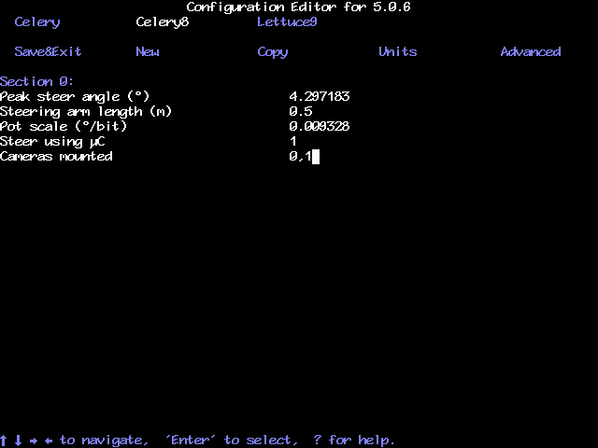
Configuration file “Section” standard editor screen

Camera settings
The first camera setting relates to the bus that the camera is mapped onto and should not be changed; it should be the same as the camera number above in blue. The second camera setting allows the user to select either “colour” infra red (“IR”) cameras. The next three settings relate to camera mounting geometry as illustrated below. Camera height is the vertical distance in m (or inches with imperial units set) from ground level to the camera lens when the implement is at its normal working height. Look ahead is the horizontal distance from a point directly below the centre of the camera lens the centre of the image in the ground plane (depicted by cross hairs in “align” mode). Distance ahead of the tines is the horizontal distance in m (or inches with imperial units set) from a point vertically below the camera lens back to the cultivator blades.
“Look ahead” (m)
Height (m)
“Distance ahead of rotors” (m)
The next settings relate to what is seen in the image. The number of rows, spacing between rows and the spacing between plants within the row.
It is the number of rows entered here that determines how many rows are used to construct the template. The machine will accept any number between 1 and 5.
The spacing between rows is normally uniform across the field of view and is therefore a single figure. However, some crop geometries with a number of different row spacings in the same scene require a more complex arrangement. The syntax for this is based on the assumption that the pattern is symmetrical about the centre line and starts with the central row spacing working out to the edge. Figures are comma delimited. In the case of an even number of rows the first figure is always the whole row spacing, not the distance from the centre line to the next row. The following examples cover likely configurations.
Odd no of rows irregular spacing example
Rows 5
Spacing 0.4,0.5
0.5m
0.4m
0.4m
0.5m
Even no of rows regular spacing example
Rows 4
Spacing 0.4
0.4m
0.4m
0.4m
The spacing between plants is the nominal within-the-row spacing and is best determined by measuring an average from a sample in the field. In doing this calculation it is best to ignore very large gaps due to missing plants.

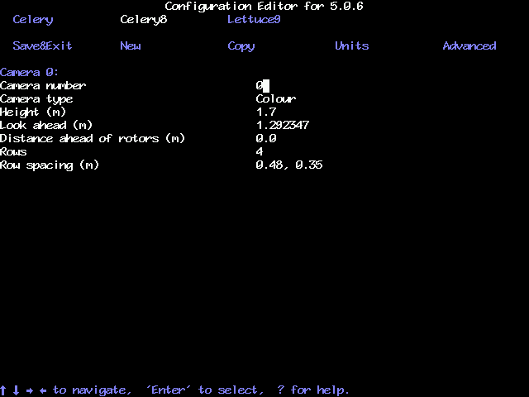
Configuration file “Camera” standard editor screen

Microcontroller settings
This page allows the user to select which crop rows are allocated to the microcontroller rotor control channels. Normally rows would be allocated to the channels in ascending numeric order up to a maximum of five rows. If a machine has more than five rows in is necessary to use an additional microcontroller.
For machines which are sometimes configured to use fewer rows than the number of rotors fitted it may be mechanically convenient to take the blade off a central unit and stop it turning. In that case the channel corresponding to the unused rotor is allocated row “ -1” which is a code that will cause that channel not to be used. For example, a single camera, single microcontroller board machine is equipped with five rotors for five rows. Under normal circumstances cultivating all five rows the row number allocation would be: 0, 1, 2, 3, 4. If however the same machine was to be used on a four row crop using the outer two rotors on each side then the allocation would be: 0, 1,-1 ,2 ,3.
Note that row numbers like camera, section and microcontroller numbers start from number 0.
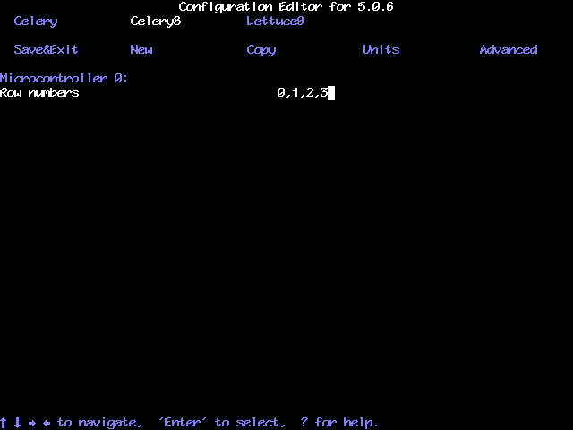
Configuration file “Microcontroller” standard editor screen

Additional settings available from the advanced editor
Under normal circumstances it should not be necessary to alter any of the additional parameters listed in the advanced editor. Please consult Garfords before making any changes.
Additional general settings
The advanced version allows the user to enter the number of cameras and microcontrollers fitted.
Odometer scale relates to the distance travelled between counts from the encoder fitted to the odometer wheel. It is calculated from the pulses per revolution (PPR = 4096) of the encoder and the diameter of the ground engaging wheel according to the formula: PI x Wheel diameter / PPR.
It is also possible to allocate to which of the microcontrollers the lift sensor is connected.
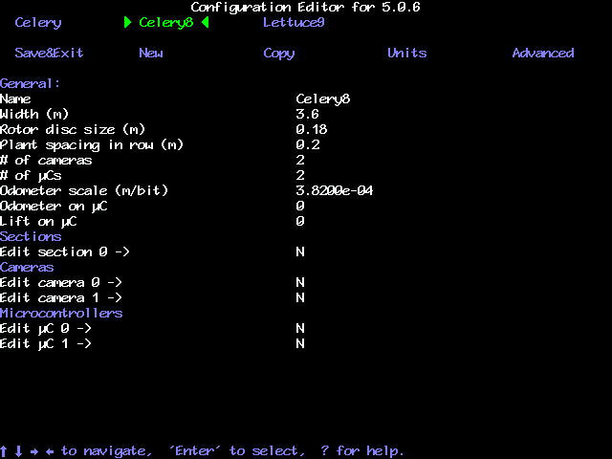
Configuration file editor screen with advanced settings selected

Additional section settings
This version of the screen allows the user to alter the value of potentiometer reading that is defined as central (normally 2048). The damping term relates to disc steering. It is also possible to define which microcontroller is used to control section steering. Finally the cameras mounted on that section are allocated.
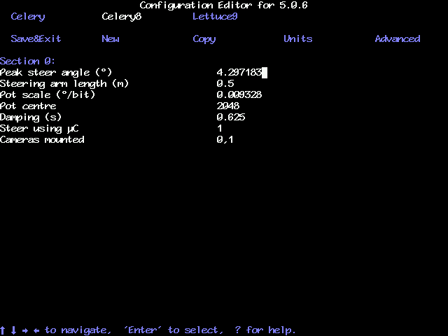
Configuration file “Section” advanced editor screen

Additional camera settings
The only additional camera parameters are the lens focal length and figure relating to correcting for camera distortion.
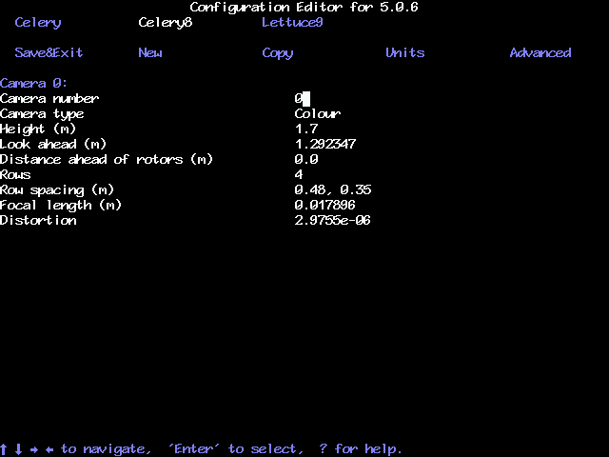
Configuration file “Camera” advanced editor screen

Odometer scale relates to the distance travelled between counts from the encoder fitted to the odometer wheel. It is calculated from the pulses per revolution (PPR = 4096) of the encoder and the diameter of the ground engaging wheel according to the formula: PI x Wheel diameter / PPR.

Maintenance and Storage

Please follow the maintenance and storage instructions below in order to ensure your Robocrop precision guided implement stays in first class working order

- There are no lubrication points on the side shift.

- Check that dirt does not build up on the side shift rails and rollers and clean if necessary. However, take care not to pressure wash electrical components such as the potentiometer, camera, solenoid valves, or micro-controller box.

- Regularly check the routing of hoses and cables and protect against chaffing.

- Always store the hoe fully undercover. Although the camera, loom and computer box are shower proof damage may result if they are exposed to wet weather for extended periods.

- The console and camera should always be stored in a dry atmosphere.

- Always ensure the correct 20 amp fuse is fitted in the power supply.

- Always ensure the correct supply polarity is adhered to.
Blue = negative, Brown/Orange/Black + (fused side) = positive.

- Always ensure the correct oil flow direction is followed Red=supply, Blue=return.

Trouble shooting
Problems have been divided into three categories listed below. Please consult your Garford dealer for any other problems.
- Console fails to start up correctly
- Console shows a working screen but the side shift/steered discs do not respond
- All systems appear to be functioning but crop tracking performance is poor
1. Console fails to start up correctly

Is there a live video image?
Check that the image responds to movement in front of the camera.
Check camera connections.
If problem persists consult dealer

Does the working screen appear?
Does any text appear on the screen?
Make a note of any messages at the bottom of the screen and consult your dealer
Check that the console has a 12v supply
Check fuse in loom near battery connection
Check connection to battery
Check voltage at power supply plug on console, minimum 12volts
If problem persists consult dealer

Yes
No
Yes
No

2. Console shows a working screen but the side shift/steered discs do not respond
Is the video image live? Check that the image responds to movement in front of the camera
Switch to manual side shift/steer control (Sk 2, working screen) and exercise the side shift/steer.

Shut down the console and restart. If the problem persists consult your dealer
Does the side shift mechanism centre when the implement is raised?
Follow fault finding procedure for poor crop tracking performance
Is the implement lift icon displayed and do the crosses overlaid on the video screen disappear when the implement is lifted?
Yes
No
Manual side shift OK
Manual side shift not OK
Check that the implement raise sensor is operating correctly. The sensor detects a magnet on the parallel linkage. It may be out of adjustment or damaged

Run the hydraulic test function from the advanced diagnostics menu. If problems persist consult your dealer
Yes
No
No
Does Robocrop’s speed indicator show a similar value to the tractors and does the stopped brake icon disappear when moving?
Check the speed sensor wheel is touching the ground and rotating. Ensure it is not damaged and correctly connected.

Yes
No
Yes
Check hydraulic supply is on and correctly connected
3. All systems appear to be functioning but crop tracking performance is poor
With the implement in work do the green/blue crosses appear symmetrically in the image and aligned with crop plants? (Use the “Align” function from the working screen)
Appropriate configuration file selected?
Select an appropriate file from the set up menu. If an appropriate file is not available either create one using the configuration editor or consult your dealer
The camera may not be correctly adjusted or an inappropriate crop height selected, refer to Section 5 of the manual
With the implement in work do crosses appear in the image over plants and does the lift icon go away?
Symptoms of poor vision tracking? i.e.
Yellow or red crosses moving erratically
Persistent tracking warning triangle
Low image quality < 1/3
The lift sensor may be damaged or incorrectly fitted
Does the side shift pull off to full stroke almost immediately on moving forward?
Both potentiometer and hydraulics may be connected the wrong way round
Check the odometer wheel is rotating and its connections are OK
Does the image freeze and image quality bar dip intermittently?
Does Robocrop’s speed indicator register a value similar to that of the tractor and the stopped icon go away?
Do the side shift or steering discs appear to oscillate rapidly or act very slowly?
The hydraulic flow rate may be set too high/low, run hydraulic test from the advanced diagnostics menu
Ensure that steering or stabilizer discs engage soil adequately and that check chains are tight. If problems persist consult your dealer
Is the lens dirty?
Clean lens
Has the camera been changed or disturbed?
Reset camera skew angle from the advanced diagnostics menu
Is the crop predominately green?
Red crops require a special camera Consult your dealer
Very small crops or severe weed infestation can under some conditions be difficult to track. If problems persist consult your dealer
The lift sensor may be poorly adjusted and operating when depth wheels follow ground contours
No
Yes
Yes
No
Yes
Yes
Yes
Yes
Yes
Yes
Yes
Yes
No
No
Yes
No
No
No
No
Yes
No
No
No
Do the green “align” lines appear skewed?
Reset camera skew from advanced diagnostics menu
No
Yes
Is lateral positioning adequate
No
Are the rotor units consistently cultivating either ahead or behind the crop plants?
Use fine offset to adjust phase
Restart the system to run another rotor start up test. If problems persist consult your dealer
No
Yes

Garford Farm Machinery
Frognall, Deeping St James,
Peterborough. PE6 8RR England
Tel. 01778 342642. Fax. 01778 348949
Email – info@garford.com

