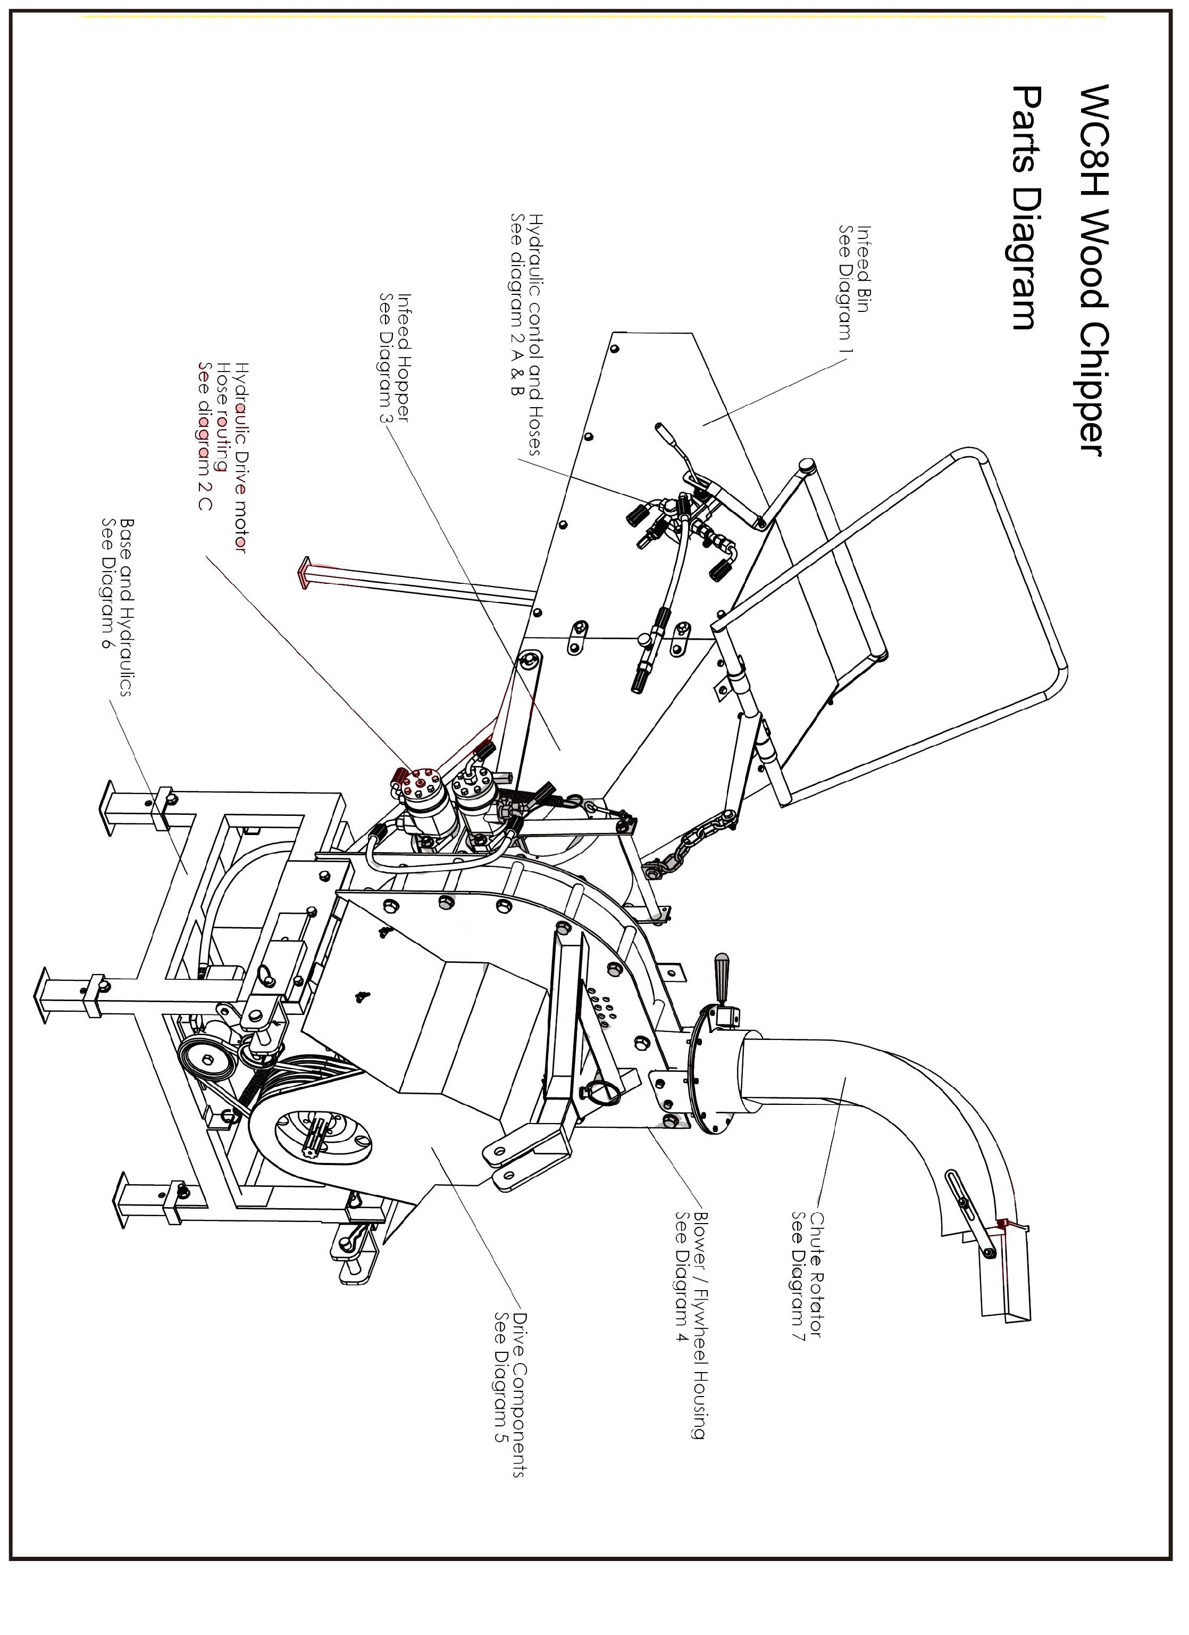
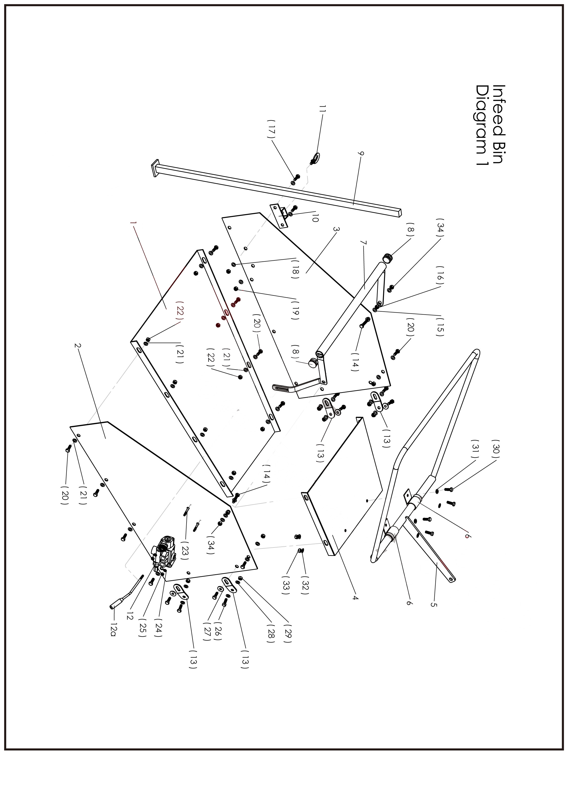
PARTS LIST
PARTS LIST
WC-8H Hydraulic Wood Chipper
Infeed Bin Parts Diagram 1
No | Parts Number | Part Description | Size / Detail |  | Qty
1 | WC8H.1.1 | Lower bin sheet metal section |  |  | 1
2 | WC8H.1.2 | Right side bin sheet metal section |  |  | 1
3 | WC8H.1.3 | Left side bin sheet metal section |  |  | 1
4 | WC8H.1.4 | Upper bin sheet metal section |  |  | 1
5 | WC8H.1.5 | Lift lever |  |  | 1
6 | WC8H.1.6 | Lift lever mount brackets |  |  | 2
7 | WC8H.1.7 | Safety bar |  | option parts | 1
8 | WC8H.1.8 | Safety bar end plugs |  | option parts | 2
9 | WC8H.1.9 | Bin support leg |  |  | 1
10 | WC8H.1.10 | Support leg bracket |  |  | 1
11 | WC8H.1.11 | Support leg bracket lock bolt (eye bolt ) | M10 |  | 1
12 | WC8H.1.12 | Hydraulic control valve |  | See detail in hydraulics section | 1
12a | WC8H.1.12A | Hydraulic control lever |  | See detail in hydraulics section | 1
13 | WC8H.1.13 | Bin attachment brackets |  |  | 4
14 | WC8H.1.14 | Bolt, Safety handle mounting | M10 x 40mm |  | 2
15 | WC8H.1.15 | flat washer | M10 | option parts | 8
16 | WC8H.1.16 | Nut ( plain used as spacer) | M10 | option parts | 2
17 | WC8H.1.17 | Bolt, support leg bracket | M10 x 25mm |  | 2
18 | WC8H.1.18 | Flat washer | M10 |  | 2
19 | WC8H.1.19 | Lock nut | M10 |  | 10
20 | WC8H.1.20 | Bolt, bin assembly | M10 x 25mm |  | 10
21 | WC8H.1.21 | Flat washer | M10 |  | 20
22 | WC8H.1.22 | Lock nut | M10 |  | 10
23 | WC8H.1.23 | Bolt, for hydraulic control mount | M8 x 60mm |  | 2
24 | WC8H.1.24 | Flat washer | M8 |  | 4
25 | WC8H.1.25 | Lock nut | M8 |  | 2
26 | WC8H.1.26 | Bolt, bin attachment clips | M10 x 25mm |  | 8
27 | WC8H.1.27 | Fender washer | M10 |  | 4
28 | WC8H.1.28 | Flat washer | M10 |  | 12
29 | WC8H.1.29 | Lock nut | M10 |  | 8
30 | WC8H.1.30 | Bolt, lift lever brackets | M10 x 25mm |  | 4
31 | WC8H.1.31 | Flat washer | M10 |  | 4
32 | WC8H.1.32 | Flat washer | M10 |  | 4
33 | WC8H.1.33 | Lock nut, lift lever | M10 |  | 4
34 | WC8H.1.34 | Lock nut, safety bar | M10 | option parts | 2

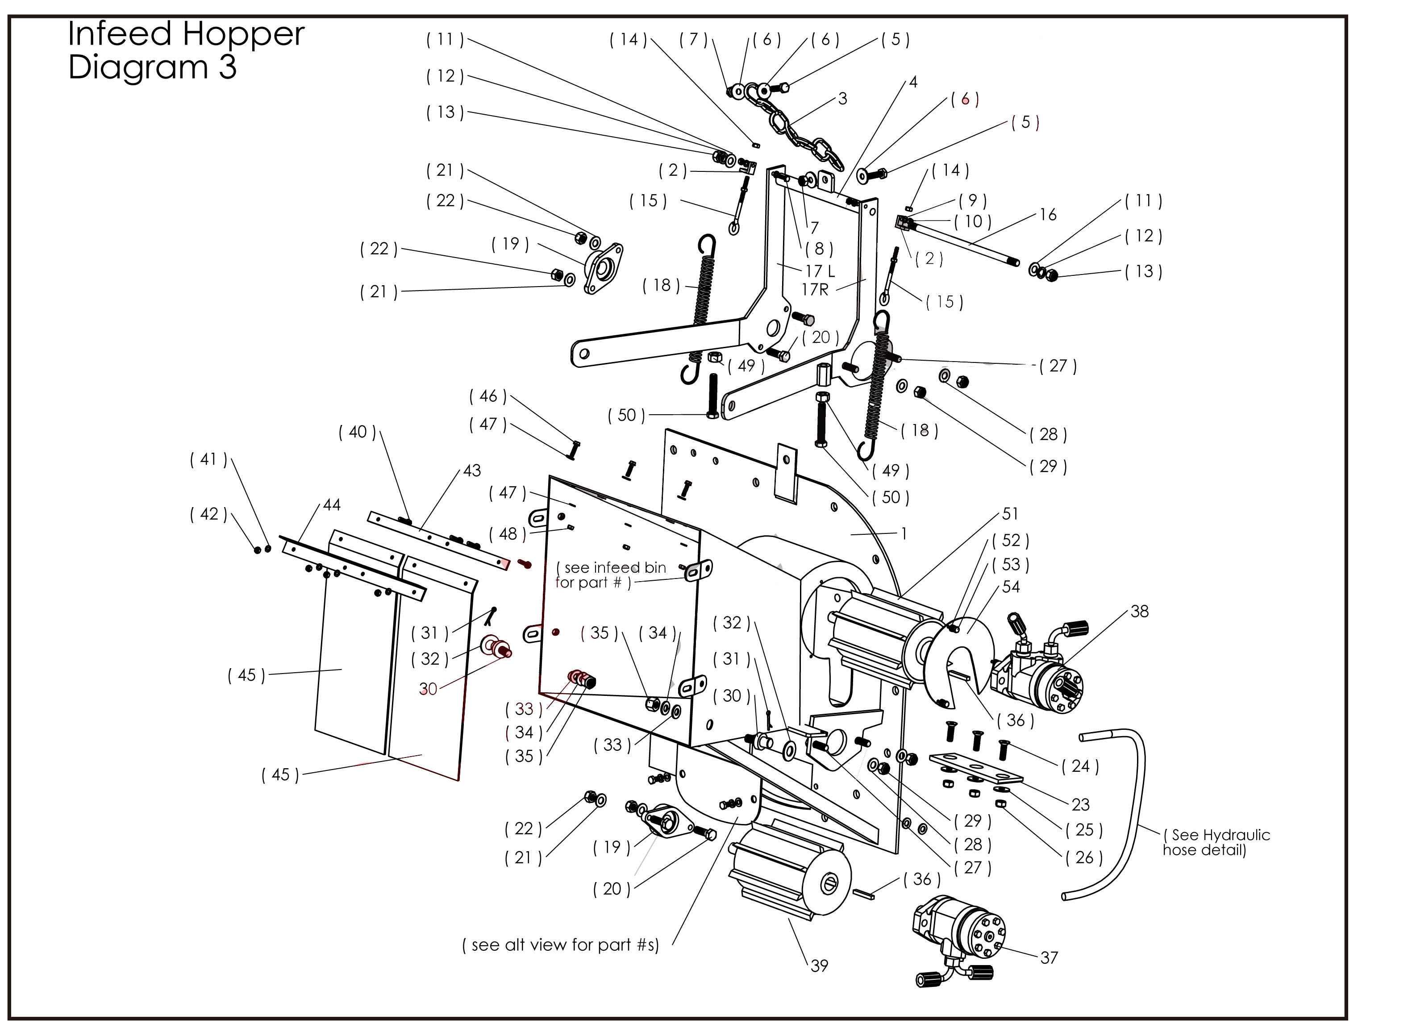

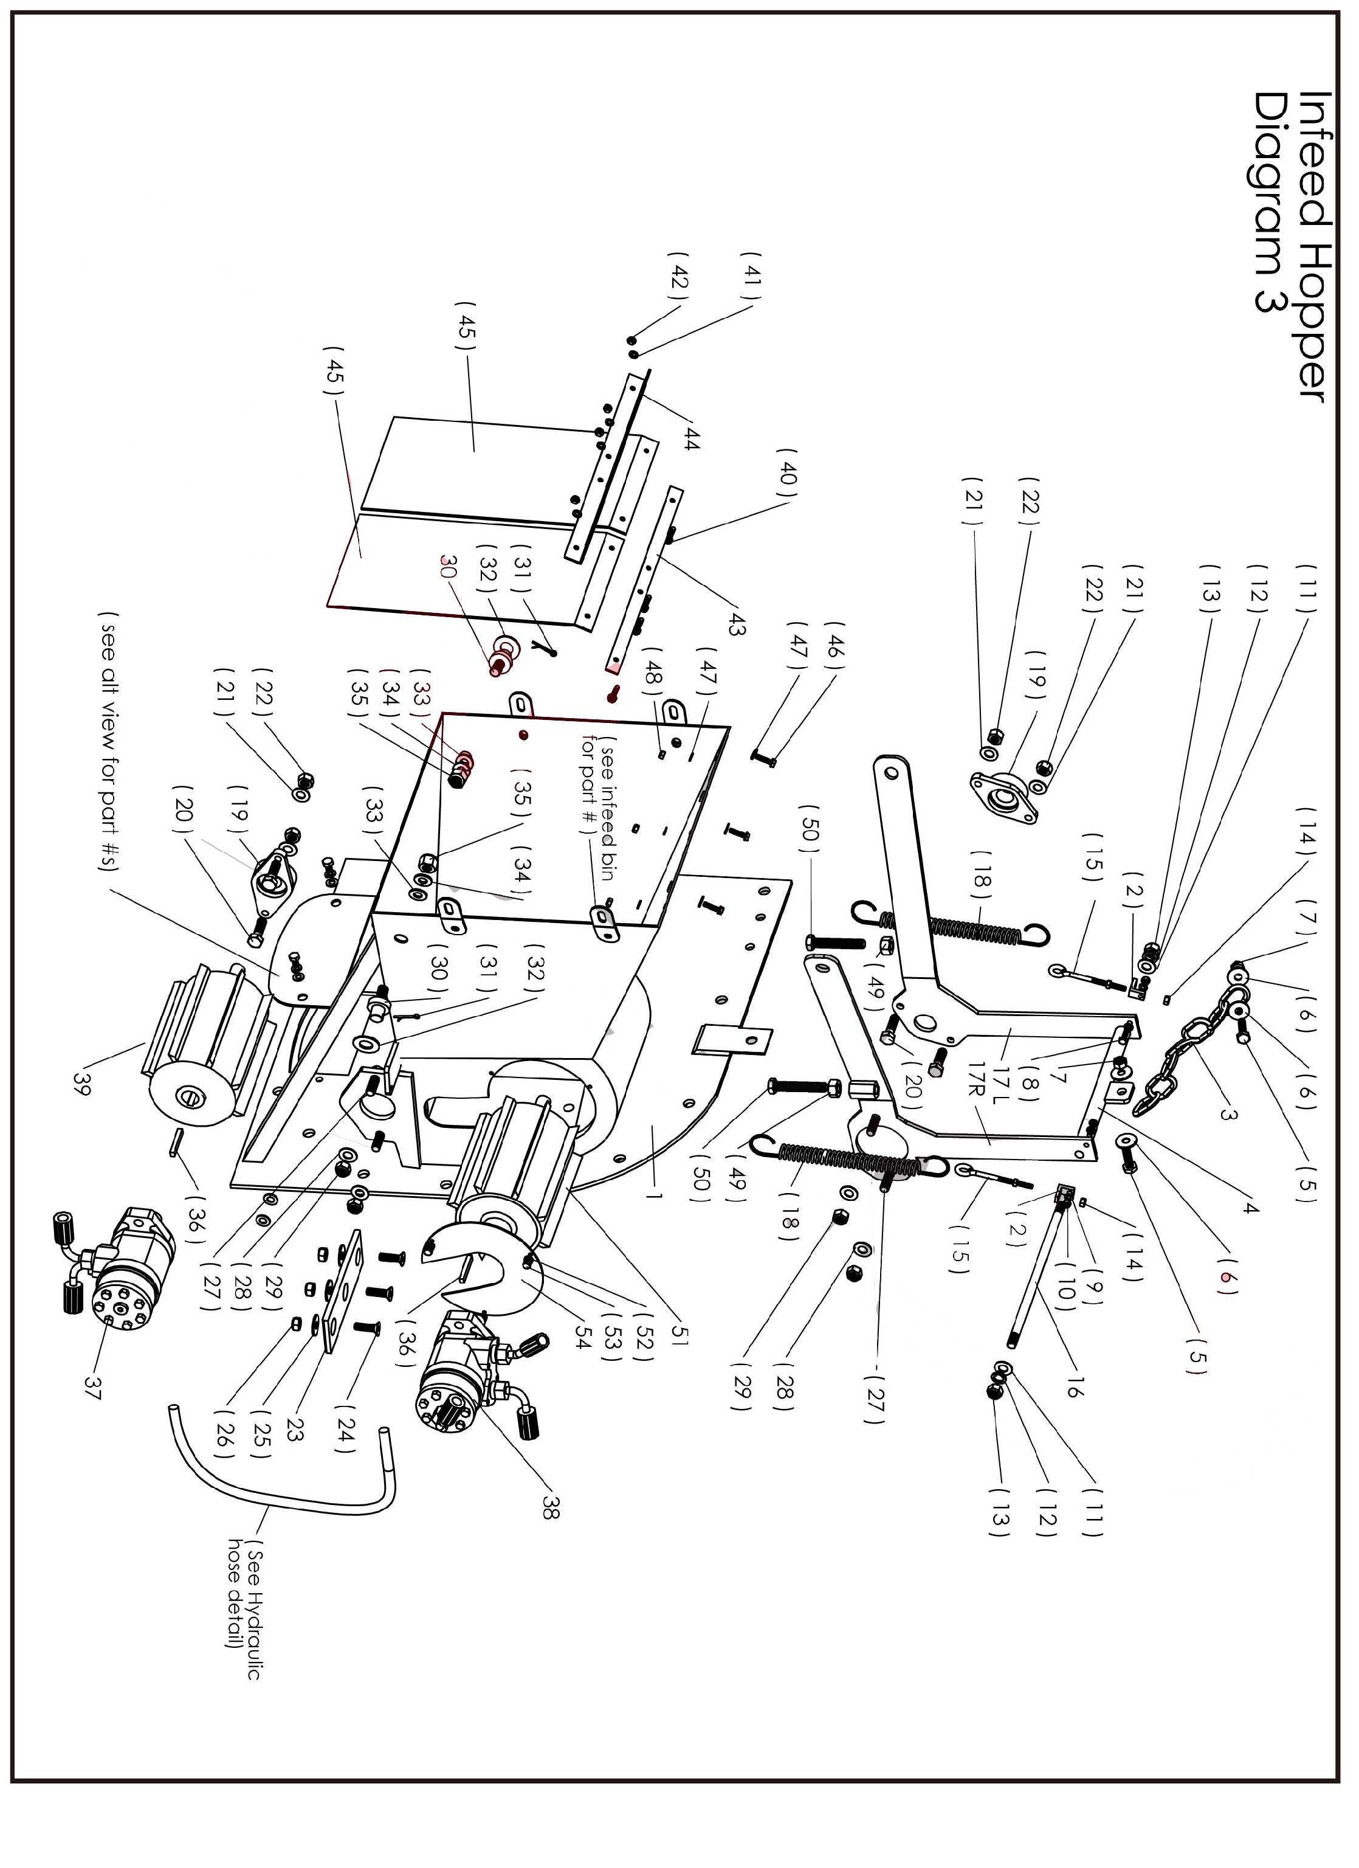
PARTS LIST

PARTS LIST
WC-8H Hydraulic Wood Chipper
Infeed Hopper Parts Diagram 3
No | Parts Number | Part Description | Size / Detail |  | Qty
1 | WC8H.3.1 | Hopper / blower half welment |  |  | 1
2 | WC8H.3.2 | Angle bracket for liftsping eye bolt |  |  | 2
3 | WC8H.3.3 | Chain, lift lever attachment |  |  | 1
4 | WC8H.3.4 | Roller lift arm cross tube |  | option parts | 1
5 | WC8H.3.5 | Bolt, Chain attachment | M10 x 35mm | option parts | 2
6 | WC8H.3.6 | Large flat washers | M10 | option parts | 4
7 | WC8H.3.7 | Lock nut | M10 | option parts | 2
8 | WC8H.3.8 | Bolt, eyebolt mounting bracket | M6 x 25mm | option parts | 2
9 | WC8H.3.9 | Flat washer | M6 | option parts | 4
10 | WC8H.3.10 | Lock nut | M6 | option parts | 2
11 | WC8H.3.11 | Flat washer | M14 | option parts | 2
12 | WC8H.3.12 | Lock washer | M14 | option parts | 2
13 | WC8H.3.13 | Lock nut | M14 | option parts | 2
14 | WC8H.3.14 | Nut, lift spring eyebolt | M6 | option parts | 2
15 | WC8H.3.15 | Eyebolt, lift spring with jamb nut | M6 x 500mm | option parts | 2
16 | WC8H.3.16 | Threaded rod, roller lift arm center tube | 14mm | option parts | 1
17 | WC8H.3.17L | Left Roller Lift arm bracket ( left side ) |  |  | 1
 | WC8H.3.17R | Right Roller Lift arm bracket ( Right side ) |  |  | 1
18 | WC8H.3.18 | Roller tension spring |  |  | 2
19 | WC8H.3.19 | Bearing 2 bolt flange, upper roller |  |  | 2
20 | WC8H.3.20 | Bolt, flange bearing | M8 x 35mm |  | 4
21 | WC8H.3.21 | Flat washer | M8 |  | 4
22 | WC8H.3.22 | Lock nut | M8 |  | 4
23 | WC8H.3.23 | Bed blade |  |  | 1
24 | WC8H.3.24 | Flat head socket cap screws, bed blade | M10 x 35mm |  | 3
25 | WC8H.3.25 | Flat washer | M10 |  | 3
26 | WC8H.3.26 | Lock nut | M10 |  | 3
27 | WC8H.3.27 | Bolt, hydr. motor mount | M12 x 40mm |  | 4
28 | WC8H.3.28 | Flat washer | M12 |  | 4
29 | WC8H.3.29 | Lock washer | M12 |  | 4
30 | WC8H.3.30 | Pivot pin, roller lift arm | M14 |  | 2
31 | WC8H.3.31 | Cotter pin |  |  | 2
32 | WC8H.3.32 | Washer, large outer | M14 |  | 2
33 | WC8H.3.33 | Flat washer | M14 |  | 2
34 | WC8H.3.34 | Lock washer | M14 |  | 2
35 | WC8H.3.35 | Lock nut | M14 |  | 2
36 | WC8H.3.36 | Shaft Key, motor shaft |  |  | 2
37 | WC8H.3.37 | Lower hydraulic motor |  |  | 1
38 | WC8H.3.38 | Upper hydraulic motor |  |  | 1
39 | WC8H.3.39 | Lower infeed roller |  |  | 1
40 | WC8H.3.40 | Bolt, baffle mounting | M6 x 30mm |  | 4
41 | WC8H.3.41 | Flat washer | M6 |  | 8
42 | WC8H.3.42 | Lock nut | M6 |  | 4
43 | WC8H.3.43 | Flat bracket, baffle mounting |  |  | 1
44 | WC8H.3.44 | Angle bracket, baffle mounting |  |  | 1
PARTS LIST
No | Parts Number | Part Description | Size / Detail |  | Qty
45 | WC8H.3.45 | Baffle |  |  | 2
46 | WC8H.3.46 | Bolt, Baffle assembly mounting | M6 x 30mm |  | 3
47 | WC8H.3.47 | Flat washers for baffle assembly mounting | M6 |  | 6
48 | WC8H.3.48 | Lock nut | M6 |  | 3
49 | WC8H.3.49 | Nut, jam nut | M12 |  | 2
50 | WC8H.3.50 | Bolt, roller gap adjustment | M12 x 65mm |  | 2
51 | WC8H.3.51 | Feed roller, upper |  |  | 1
52 | WC8H.3.52 | Flat and Lock washer | M6 |  | 3
53 | WC8H.3.53 | Bolt, roller Access cover plate | M6 x 12mm |  | 3
54 | WC8H.3.54 | Cover plate, roller access |  |  | 1

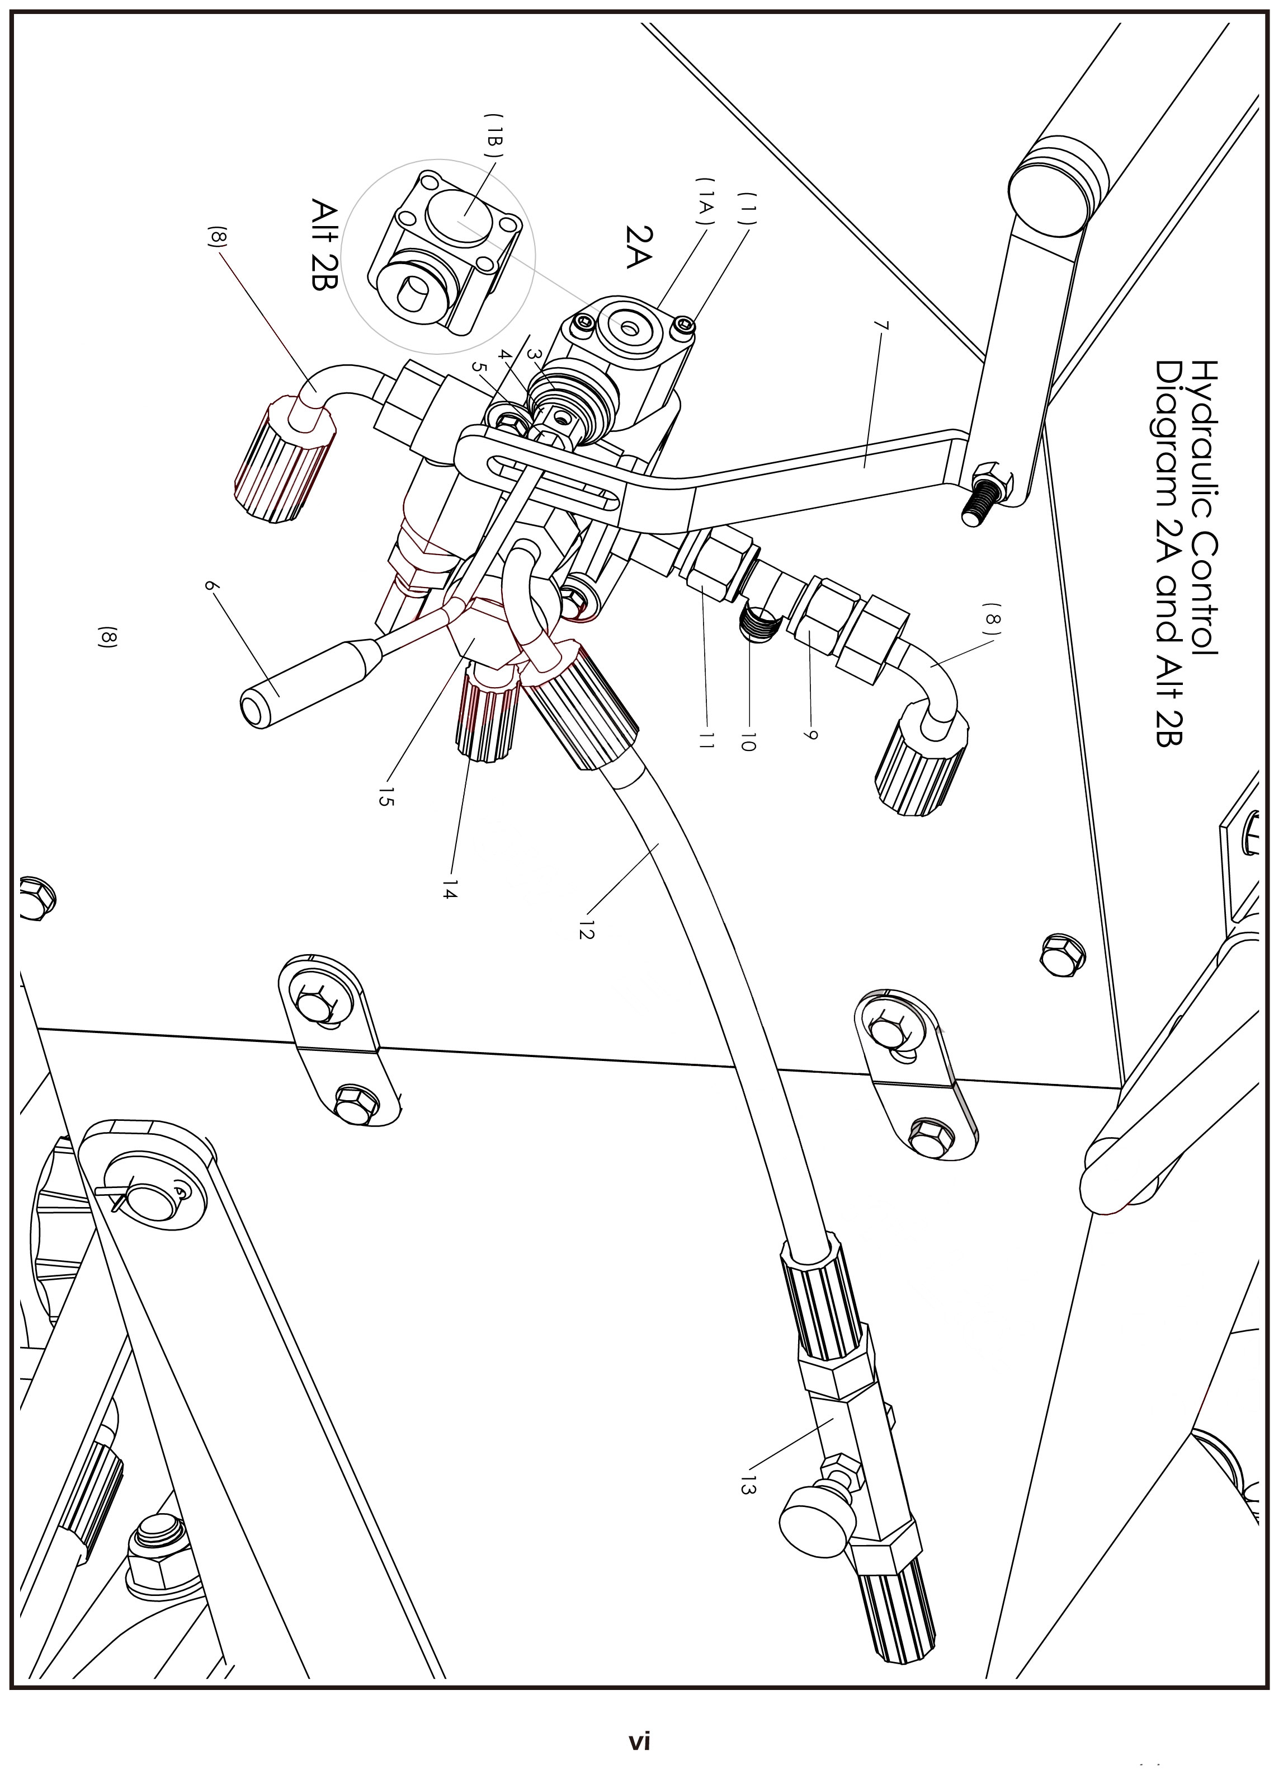
PARTS LIST

PARTS LIST
WC-8H Hydraulic Wood Chipper
Infeed Hopper Parts Diagram 2A & 2B
No | Parts Number | Part Description | Size / Detail |  | Qty
1 | WC8H.2A.1 | Cap screws | M6 x 60mm |  | 2
1a | WC8H.2A.1A | A Trapeziod Control valve |  |  | 1
2 | WC8H.2A.2 | Hydraulic control body |  |  | 1
3 | WC8H.2A.3 | Rubber lever boot |  |  | 1
4 | WC8H.2A.4 | Valve actuator |  |  | 1
5 | WC8H.2A.5 | Jam nut,control lever | M6 |  | 1
6 | WC8H.2A.6 | Control lever |  |  | 1
7 | WC8H.2A.7 | Safety bar |  | option parts | 1
8 | WC8H.2A.8 | 90 degree outlet fitting & hose Hose routes to top motor center |  |  | 1
9 | WC8H.2A.9 | Coupler fitting |  |  | 1
10 | WC8H.2A.10 | T- fitting |  |  | 1
11 | WC8H.2A.11 | Coupler fitting |  |  | 1
12 | WC8H.2A.12 | 90 degree outlet fitting & hose Hose routes to top motor |  |  | 1
13 | WC8H.2A.13 | Flow control valve |  |  | 1
14 | WC8H.2A.14 | Hose fitting and hose Hose routes to lower motor |  |  | 1
15 | WC8H.2A.15 | Banjo fitting |  |  | 1
Diagram 2 B Part Description
No | Parts Number | Part Description | Size / Detail |  | Qty
1 | WC8H.2B.1 | Cap screws |  |  | 2
1B | WC8H.2B.1B | Square control valve |  |  | 1

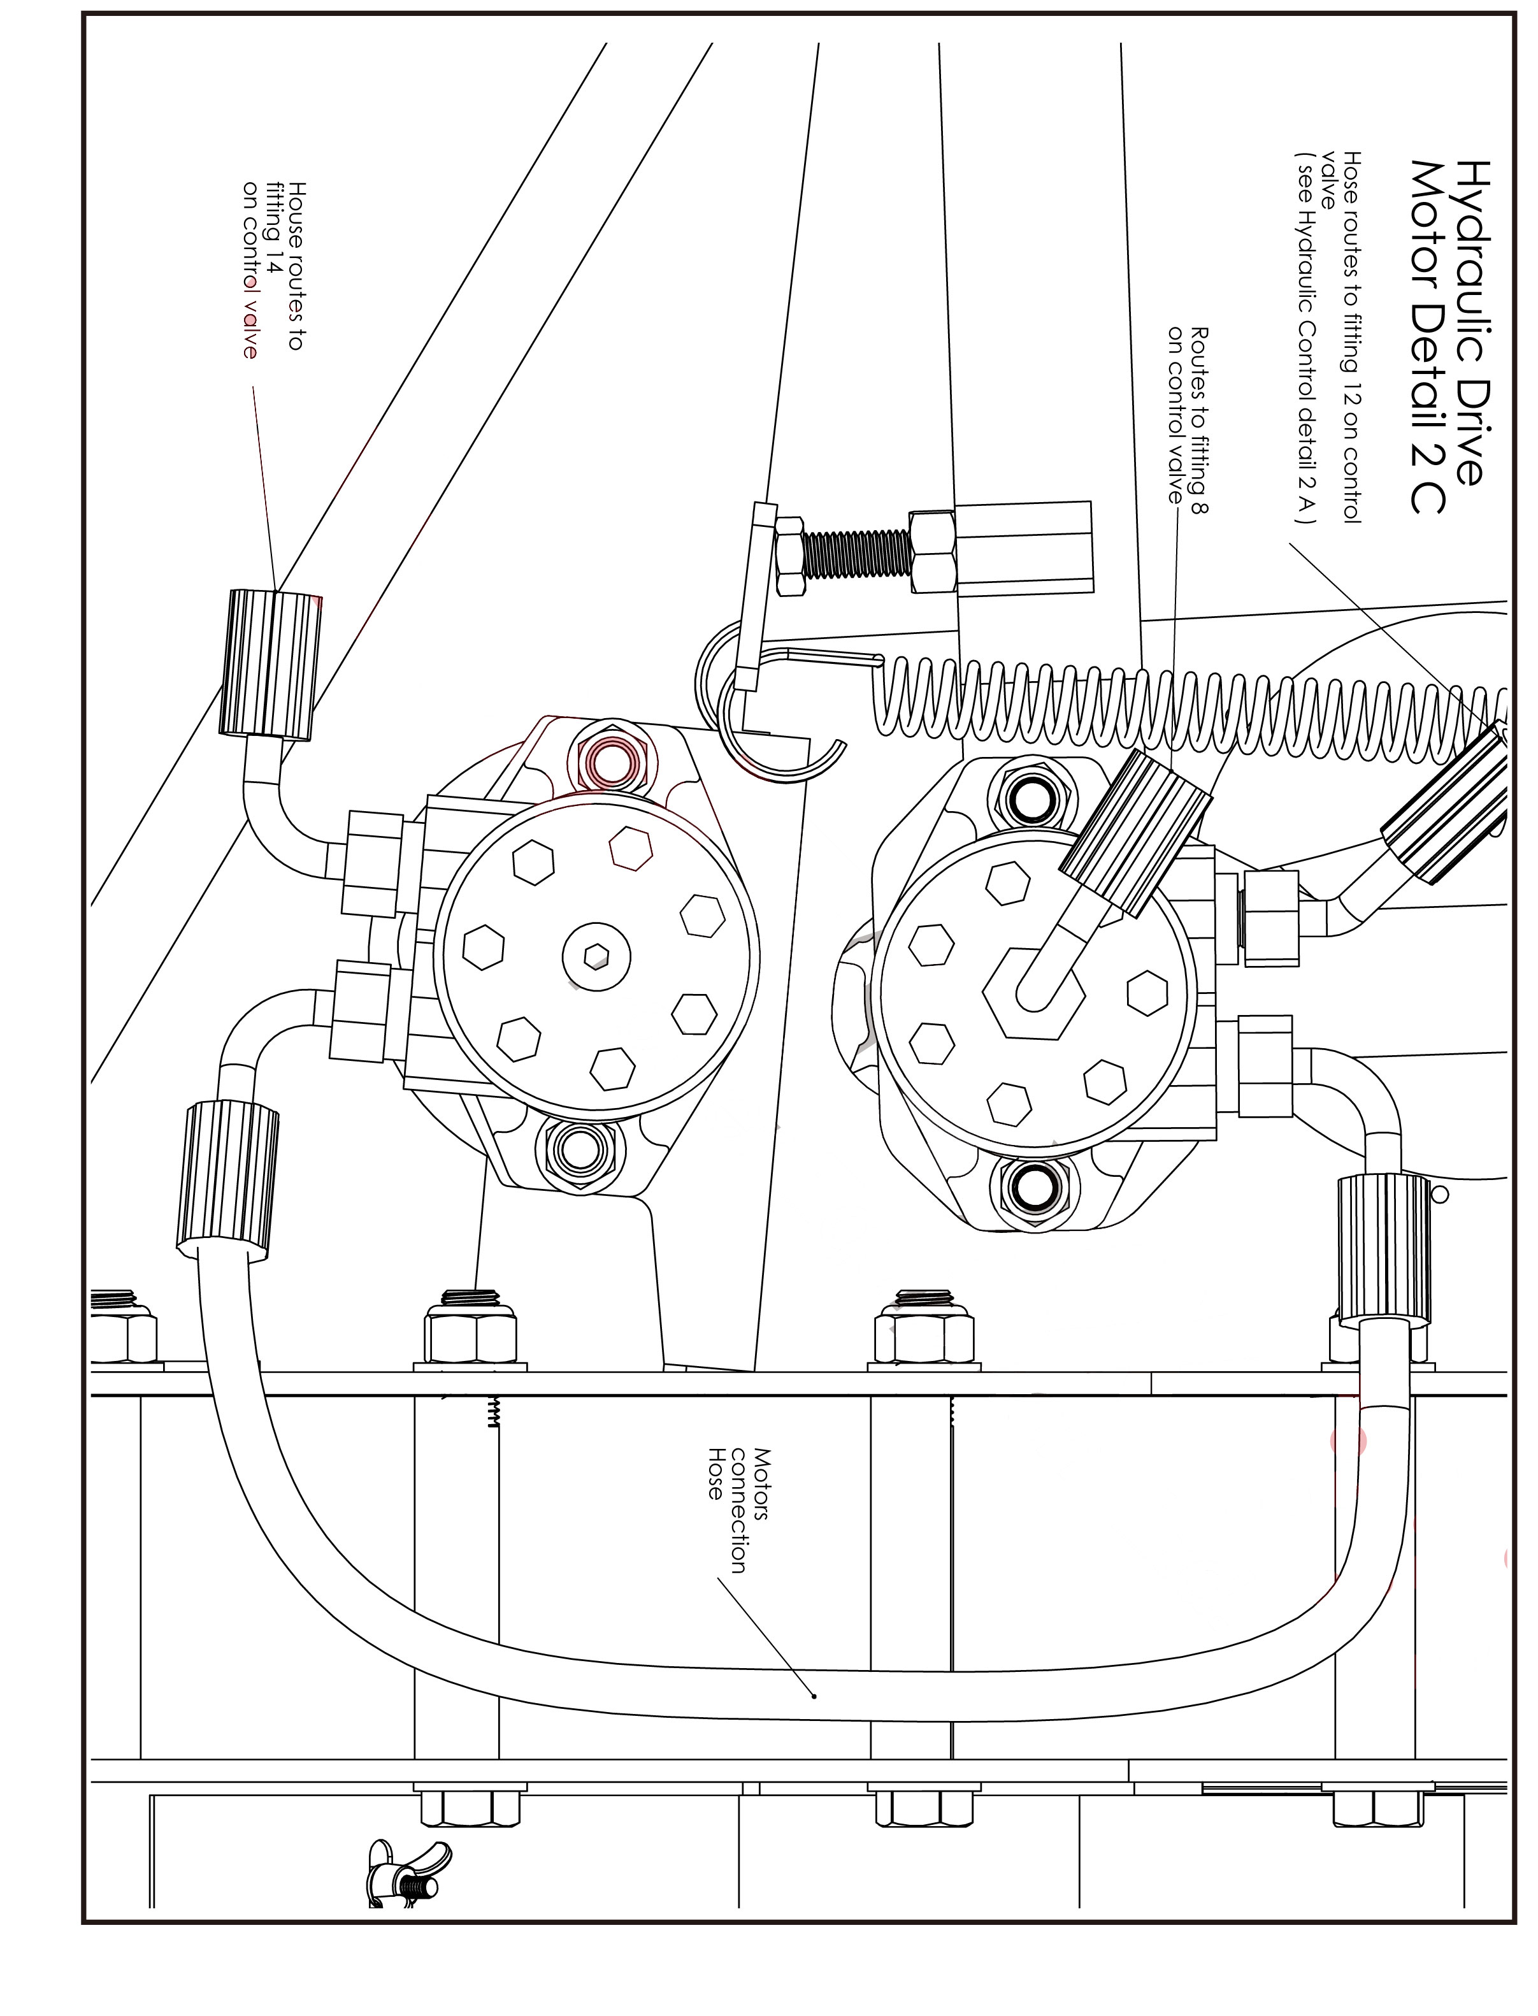
PARTS LIST

PARTS LIST
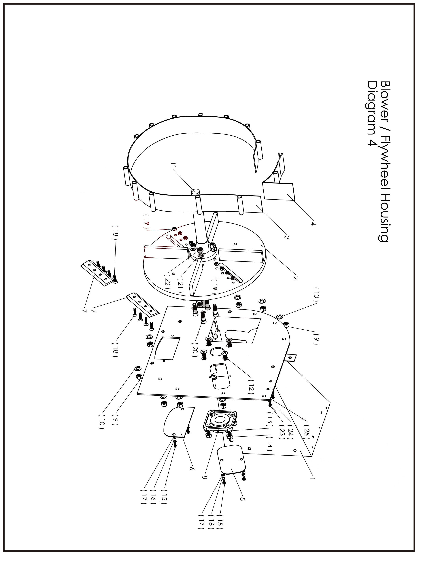

PARTS LIST
WC-8H Hydraulic Wood Chipper
Blower / Flywheel housing Parts Diagram 4
No | Parts Number | Part Description | Size / Detail |  | Qty
1 | WC8H.4.1 | Hopper / blower half weldment duplicte view of part |  | see Diagram 3 | 1
2 | WC8H.4.2 | Flywheel fan weldment |  |  | 1
3 | WC8H.4.3 | Blower radius housing |  |  | 1
4 | WC8H.4.4 | Blower radius housing top section |  |  | 1
5 | WC8H.4.5 | Cover plate, knife access |  |  | 1
6 | WC8H.4.6 | Cover plate, clean out |  |  | 1
7 | WC8H.4.7 | Knife |  |  | 2
8 | WC8H.4.8 | Flange bearing 4 bolt see diagram 5 for opposite side view |  |  | 1
9 | WC8H.4.9 | Lock nut blower housing assembly |  | M16 x 140mm | 13
10 | WC8H.4.10 | Flat washer | M16 | see diagram 5 for opposite side view | 13
11 | WC8H.4.11 | Flywheel spindle shaft |  |  | 1
12 | WC8H.4.12 | Bolt flat head socket, flange bearing mount | M16 x 50mm | see diagram 5 for opposite side view | 4
13 | WC8H.4.13 | Flat washer | M16 | see diagram 5 for opposite side view | 4
14 | WC8H.4.14 | Lock nut | M16 | see diagram 5 for opposite side view | 4
15 | WC8H.4.15 | Bolt, cover plate(s) | M10 x 25mm |  | 4
16 | WC8H.4.16 | Lock washer | M10 |  | 4
17 | WC8H.4.17 | Flat washer | M10 |  | 4
18 | WC8H.4.18 | Bolt flat head socket, knife mount | M10 x 40mm |  | 8
19 | WC8H.4.19 | Lock nut | M10 |  | 8
20 | WC8H.4.20 | Bolt socket head, spindle shaft mount | M16 x 60mm |  | 4
21 | WC8H.4.21 | Flat washer | M16 |  | 4
22 | WC8H.4.22 | Lock nut | M16 |  | 4
23 | WC8H.4.23 | Bolt, Chute adapter mount | M10 x 40mm | opposite side parts see diagram 5 | 2
24 | WC8H.4.24 | Lock washer | M10 | opposite side parts see diagram 5 | 2
25 | WC8H.4.25 | Flat washer | M10 | opposite side parts see diagram 5 | 2

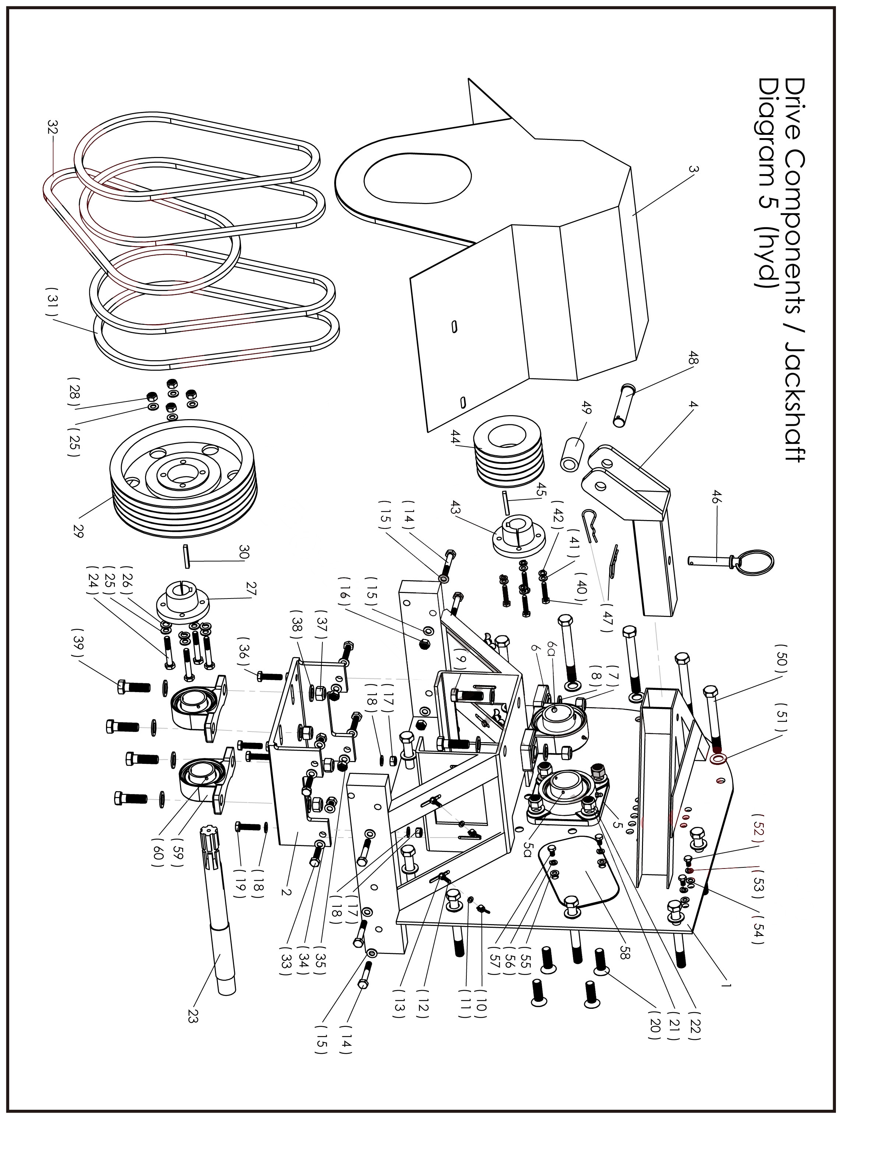
PARTS LIST
PARTS LIST
WC-8H Hydraulic Wood Chipper
Drive components / Jackshaft Diagram 5
No | Parts Number | Part Description | Size / Detail |  | Qty
1 | WC8H.5.1 | Jackshaft / blower weldment |  |  | 1
2 | WC8H.5.2 | Jackshaft bearing mounting plate |  |  | 1
3 | WC8H.5.3 | Sheave belt cover |  |  | 1
4 | WC8H.5.4 | Top link |  |  | 1
5 | WC8H.5.5 | Flange bearing 4 bolt |  | see diagram 4 for identical parts opposite side | 1
5a | WC8H.5.5A | Set screw |  |  | 2
6 | WC8H.5.6 | Pillow block flywheel spindle bearing |  |  | 1
6a | WC8H.5.6A | Set screw |  |  | 2
7 | WC8H.5.7 | Lock nuts | M16 |  | 2
8 | WC8H.5.8 | Flat washer | M16 |  | 4
9 | WC8H.5.9 | Bolt, Pillow block bearing mount | M16 x 50mm |  | 2
10 | WC8H.5.10 | Wing nut, cover mount | M8 |  | 4
11 | WC8H.5.11 | Flat washer | M8 |  | 8
12 | WC8H.5.12 | Bolt, cover mount | M8 x 30mm |  | 4
13 | WC8H.5.13 | Nut | M8 |  | 4
14 | WC8H.5.14 | Bolt, base to upper assembly | M10 x 60mm |  | 6
15 | WC8H.5.15 | Flat washer | M10 |  | 12
16 | WC8H.5.16 | Lock nut | M10 |  | 6
17 | WC8H.5.17 | Lock nut | M10 |  | 2
18 | WC8H.5.18 | Flat Washer | M10 |  | 4
19 | WC8H.5.19 | Bolt, jack shaft bearing mount plate | M10 x 30 |  | 2
20 | WC8H.5.20 | Bolt flat head socket, flange bearing mount | M16 x 50mm | see diagram 4 for identical parts opposite side | 4
21 | WC8H.5.21 | Flat washer | M16 | see diagram 4 for identical parts opposite side | 4
22 | WC8H.5.22 | Lock nut | M16 | see diagram 4 for identical parts opposite side | 4
23 | WC8H.5.23 | Jack shaft |  |  | 1
24 | WC8H.5.24 | Bolt, taper lock / jackshaft | M10 x 30mm |  | 4
25 | WC8H.5.25 | Flat washers | M10 |  | 4
26 | WC8H.5.26 | Lock washers | M10 |  | 4
27 | WC8H.5.27 | Taper lock / jackshaft to sheave |  |  | 1
28 | WC8H.5.28 | Lock nuts | M10 |  | 4
29 | WC8H.5.29 | sheave / jackshaft |  |  | 1
30 | WC8H.5.30 | Shaft key Jackshaft / Taper lock | 7/16" x 2" |  | 1
31 | WC8H.5.31 | Drive belt |  |  | 4
32 | WC8H.5.32 | Pump belt |  |  | 1
PARTS LIST
No | Parts Number | Part Description | Size / Detail |  |  | Qty
33 | WC8H.5.33 | Bolt, jackshaft mounting plate (side) | M10 x 30mm |  |  | 4
34 | WC8H.5.34 | Flat washer | M10 |  |  | 8
35 | WC8H.5.35 | Lock nut | M10 |  |  | 4
36 | WC8H.5.36 | Bolt, Jackshaft vertical alignment adjustment | M10 x 40mm |  |  | 2
37 | WC8H.5.37 | Lock nut | M14 |  |  | 4
38 | WC8H.5.38 | Flat washer | M14 |  |  | 8
39 | WC8H.5.39 | Bolt, jackshaft pillow block | M14 x 50mm |  |  | 4
40 | WC8H.5.40 | Bolt, taper lock / spindle | M8 x 40mm |  |  | 4
41 | WC8H.5.41 | Flat washer | M8 |  |  | 4
42 | WC8H.5.42 | Lock washer | M8 |  |  | 4
43 | WC8H.5.43 | Taper lock / spindle shaft to sheave |  |  |  | 1
44 | WC8H.5.44 | Sheave, spindle shaft |  |  |  | 1
45 | WC8H.5.45 | Shaft key, Taper lock / Spindle shaft | 3/8" x 2" |  |  | 1
46 | WC8H.5.46 | 46 Lock pin, top link |  | option parts |  | 1
47 | WC8H.5.47 | Spring pin |  | option parts |  | 2
48 | WC8H.5.48 | Pin, top link |  |  |  | 1
49 | WC8H.5.49 | Bushing, upper 3 point hitch adaptor |  |  |  | 2
50 | WC8H.5.50 | Bolt, housing assembly | M16 x 160mm |  |  | 13
51 | WC8H.5.51 | Flat washer | M16 | see diagram 4 for identical parts opposite side |  | 13
52 | WC8H.5.52 | Bolt, chute adapter | M10 x 25 | see diagram 4 for identical parts opposite side |  | 2
53 | WC8H.5.53 | Lock washer | M10 | see diagram 4 for identical parts opposite side |  | 2
54 | WC8H.5.54 | Flat washer | M10 | see diagram 4 for identical parts opposite side |  | 2
55 | WC8H.5.55 | Flat washer | M10 | see diagram 4 for identical parts opposite side |  | 2
56 | WC8H.5.56 | Lock washer | M10 | see diagram 4 for identical parts opposite side |  | 2
57 | WC8H.5.57 | Bolt, cover plate Knife access | M10 x 25mm | see diagram 4 for identical parts opposite side |  | 2
58 | WC8H.5.58 | Cover plate, knife |  | see diagram 4 for identical parts opposite side |  | 1
59 | WC8H.5.59 | Pillow block bearing, Jackshaft |  |  |  | 2
60 | WC8H.5.60 | Set screws | M8-1.25 x 8mm |  |  | 4

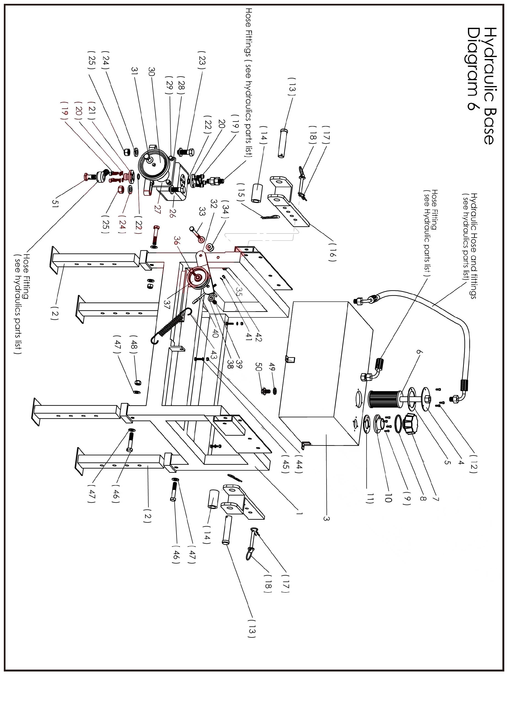
PARTS LIST
PARTS LIST
WC-8H Hydraulic Wood Chipper
Base Detail 6
No |  | Part Description | Size / Detail |  | Qty
1 | WC8H.6.1 | Frame weldment |  |  | 1
2 | WC8H.6.2 | Adjustable leg |  | option parts | 4
3 | WC8H.6.3 | Hydraulic fluid reservoir |  |  | 1
4 | WC8H.6.4 | Hydraulic fluid filter assembly |  |  | 1
5 | WC8H.6.5 | Hydraulic filter flange gasket |  |  | 1
6 | WC8H.6.6 | Filter cartridge |  |  | 1
7 | WC8H.6.7 | Filler cap |  |  | 1
8 | WC8H.6.8 | Filler cap O ring |  |  | 1
9 | WC8H.6.9 | Screws socket head | M5 x15mm |  | 4
10 | WC8H.6.10 | Filler cap flange |  |  | 1
11 | WC8H.6.11 | Filler flange gasket |  |  | 1
12 | WC8H.6.12 | Screws socket head | M5 x 15mm |  | 3
13 | WC8H.6.13 | Pin , 3 point hitch attachment ( lower ) |  |  | 2
14 | WC8H.6.14 | Bushing , 3 point hitch bracket (lower) |  |  | 2
15 | WC8H.6.15 | Cotter pin, hitch pin | 3.5mm |  | 2
16 | WC8H.6.16 | 3 point hitch bracket ( lower ) |  |  | 2
17 | WC8H.6.17 | Cotter pin, bracket lock pin | 3mm |  | 2
18 | WC8H.6.18 | Lock pin, hitch bracket |  |  | 2
19 | WC8H.6.19 | Bolt socket head, pump adapter | M8 x 16mm |  | 8
20 | WC8H.6.20 | Lock washer | M8 |  | 8
21 | WC8H.6.21 | Pump adapter fitting |  |  | 2
22 | WC8H.6.22 | O- ring, pump adapter fitting |  |  | 2
23 | WC8H.6.23 | Bolt, Hydraulic pump mount | M10 x 50mm |  | 4
24 | WC8H.6.24 | Flat fender washer | M10 |  | 8
25 | WC8H.6.25 | Lock nut, Hydraulic pump mount | M10 |  | 4
26 | WC8H.6.26 | Hydraulic pump |  |  | 1
27 | WC8H.6.27 | Thrust adapter, hydraulic pump |  |  | 1
28 | WC8H.6.28 | Lock washer | M8 |  | 4
29 | WC8H.6.29 | Bolt socket head, thrust adapter to pump | M8 x 35mm |  | 4
30 | WC8H.6.30 | Pulley, Hyd pump |  |  | 1
31 | WC8H.6.31 | Nut, Pulley mount shaft | M12 |  | 1
32 | WC8H.6.32 | Tensioner bracket, pump belt |  | option parts | 1
33 | WC8H.6.33 | Bolt, tensioner bracket mount | 3/8" x 3.5" | option parts | 1
34 | WC8H.6.34 | Flat washer , Spacers tensioner alaignment | 3/8" | option parts | 2
35 | WC8H.6.35 | Lock nut | 3/8" | option parts | 1
36 | WC8H.6.36 | Bolt, Idler pulley mount | 3/8" x 2" | option parts | 1
37 | WC8H.6.37 | Idler pulley, pump tensioner |  | option parts | 1
38 | WC8H.6.38 | Flat washer | 3/8" | option parts | 1
39 | WC8H.6.39 | Lock nut | 3/8" | option parts | 1
40 | WC8H.6.40 | Eye bolt, spring tensioner |  | option parts | 1
41 | WC8H.6.41 | Flat washer | M8 | option parts | 1
42 | WC8H.6.42 | Nut | M8 | option parts | 1
43 | WC8H.6.43 | Spring , belt tensioner |  | option parts | 1
44 | WC8H.6.44 | Nut for resevoir mount | M8 |  | 3
45 | WC8H.6.45 | Flat washer for reservoir mount | M8 |  | 3
46 | WC8H.6.46 | Bolt, adjustable leg | M12 x 60mm | option parts | 4
PARTS LIST
No |  | Part Description | Size / Detail |  | Qty
47 | WC8H.6.47 | Flat washer | M12 | option parts | 8
48 | WC8H.6.48 | Lock nut for adjustable leg | M12 | option parts | 4
49 | WC8H.6.49 | O- ring |  |  | 1
50 | WC8H.6.50 | Drain plug |  |  | 1
51 | WC8H.6.51 | Banjo bolt ( hydraulic ) |  |  | 1

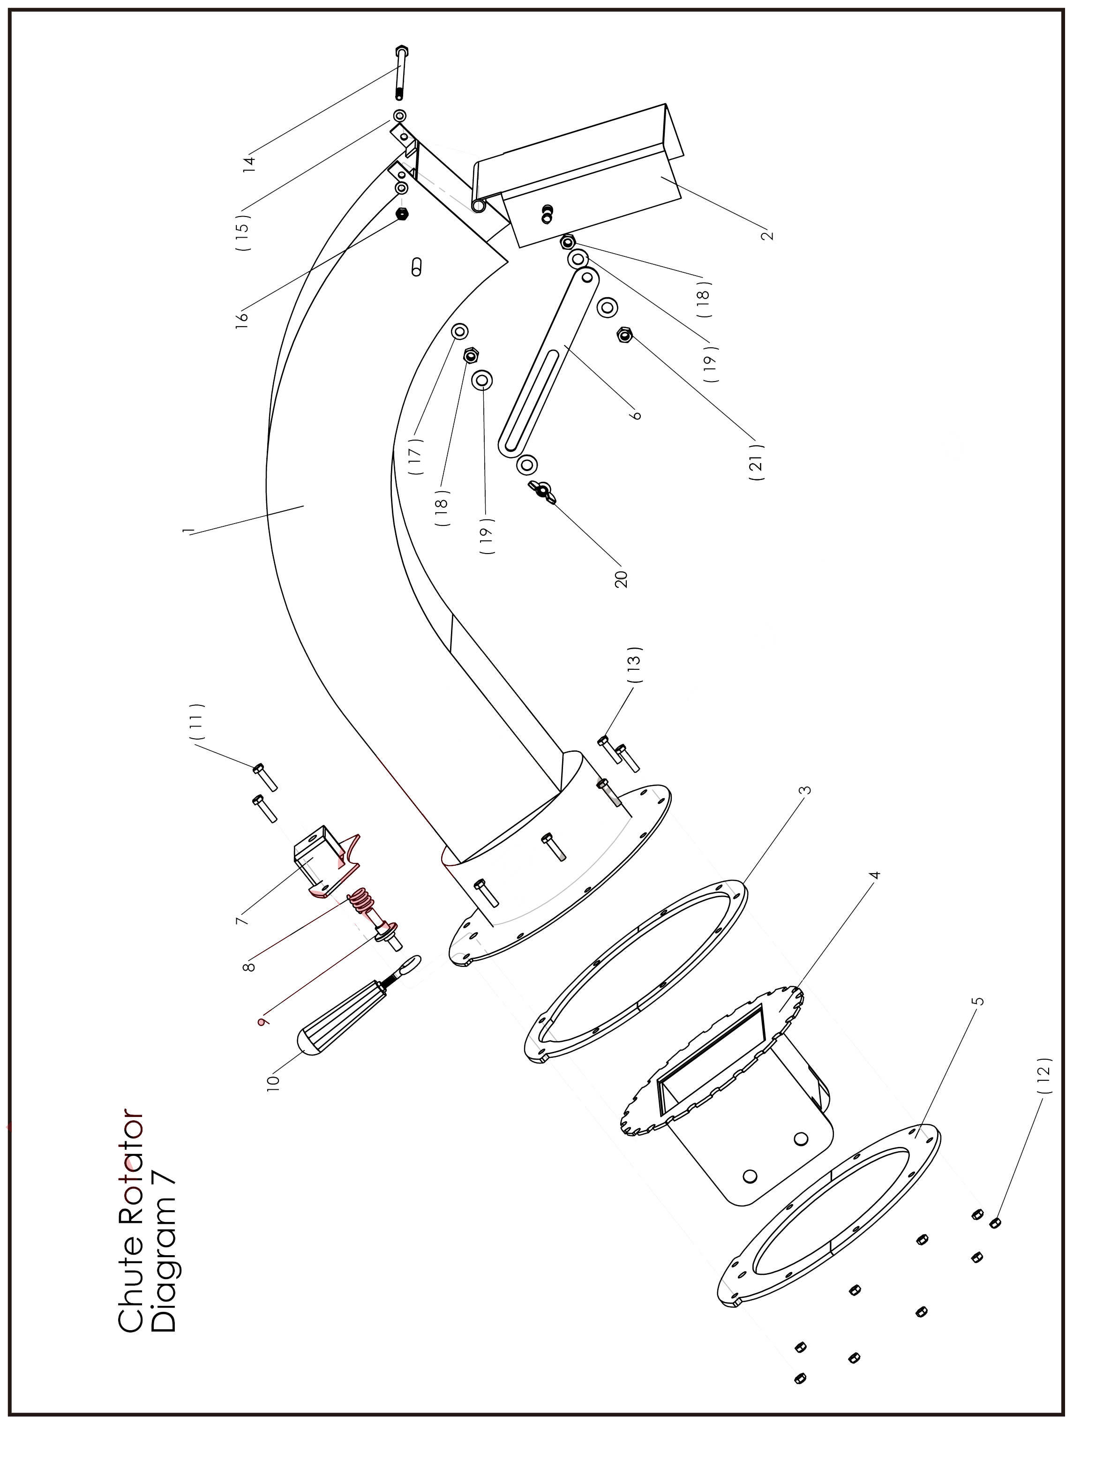
PARTS LIST

PARTS LIST
WC-8H Hydraulic Wood Chipper
Chute Rotator Diagram 7
No |  | Part Description | Size / Detail |  | Qty
1 | WC8H.7.1 | Curved riser weldment |  |  | 1
2 | WC8H.7.2 | Bonnet |  |  | 1
3 | WC8H.7.3 | Spacer ring |  | option parts | 1
4 | WC8H.7.4 | Housing adaptor weldment |  | option parts | 1
5 | WC8H.7.5 | Lower assembly ring |  | option parts | 1
6 | WC8H.7.6 | Bonnet adjustment arm |  |  | 1
7 | WC8H.7.7 | Index pin housing |  | option parts | 1
8 | WC8H.7.8 | Index spring pin |  | option parts | 1
9 | WC8H.7.9 | Index pin |  | option parts | 1
10 | WC8H.7.10 | Handle with eyebolt |  | option parts | 1
11 | WC8H.7.11 | Bolt, index pin housing | M5 x 25mm | option parts | 2
12 | WC8H.7.12 | Lock nut, rotator assembly | M5 | option parts | 8
13 | WC8H.7.13 | Bolt, rotator assembly | M5 x 20mm |  | 6
14 | WC8H.7.14 | Bolt, bonnet mount / pivot | M8 x 140mm |  | 1
15 | WC8H.7.15 | Flat washer | M8 |  | 2
16 | WC8H.7.16 | Lock nut, bonnet mount | M8 |  | 1
17 | WC8H.7.17 | Flat washer | M10 |  | 1
18 | WC8H.7.18 | Nut spacer ajustment arm | M10 |  | 2
19 | WC8H.7.19 | Flat washer |  |  | 4
20 | WC8H.7.20 | Wing nut |  |  | 1

Bowell Implement Warranty
Warranty
Bowell warrants to the original purchaser that this Bowell product will be free from defects in material and workmanship beginning on the date of purchase by the end user according to the following schedule when used as intended and under normal service and conditions for personal use.
Overall Unit and Driveline: One year Parts and Labor
Gearbox: One year on all components.
Blades and Belts: Considered wear items.
This Warranty is limited to the replacement of any defective part by Bowell and the installation by the dealer of any such replacement part, and does not cover common wear items. Bowell reserves the right to inspect any equipment or parts which are claimed to have been defective in material or workmanship.
This Warranty does not apply to any part or product which in Bowell’s judgment shall have been misused or damaged by accident or lack of normal maintenance or care, or which has been repaired or altered in a way which adversely affects its performance or reliability, or which has been used for a purpose for which the product is not designed. Misuse also specifically includes failure to properly maintain oil levels, grease points, and driveline shafts.
Claims under this Warranty should be made to the dealer which originally sold the product and all warranty adjustments must be made through an authorized Bowell dealer. Bowell reserves the right to make changes in materials or design of the product at any time without notice.
This Warranty shall not be interpreted to render Bowell liable for damages of any kind, direct, consequential, or contingent to property. Furthermore, Bowell shall not be liable for damages resulting from any cause beyond its reasonable control. This Warranty does not extend to loss of crops, any expense or loss for labor, supplies, rental machinery or for any other reason.
No other warranty of any kind whatsoever, express or implied, is made with respect to this sale; and all implied warranties of merchantability and fitness for a particular purpose which exceed the obligations set forth in this written warranty are hereby disclaimed and excluded from this sale.
This Warranty is not valid unless registered with Bowell within 30 days from the date of purchase by the end user.

